User Manual for Panchayati Raj Project Management System (PPMS)



Compiled by:

Panchayati Raj & Drinking Water Department


Prepared by:


Table of Contents
1. Introduction 4
2. Scope 5
5th SFC GIA Scheme to be implemented at Panchayat Samiti Level (Block Level). 5
3. About Panchayati Raj and Drinking Water Department 6
4. Purpose of User Manual 6
5. User Functionalities 7
5. Dashboard 8
6 Process Flow 10
7. Block User 14
7.1 BDO responsible for Entry New Project 18
7.2 For Uploading Sanction Letter: 20
7.3 BDO User- Assign Developmental Assistant for case record Preparation 21
8. DA User- Prepare case record (Land Report) 23
8.1 DA User- Prepare case record (Order Sheet) 25
8.2 DA User- Prepare case record (Upload Supporting Document) 26
8.3 DA User- Forward case record to BDO 27
9. BDO User- Verify Case Record (Order Sheet) 28
9.1 BDO User Verify Land Report: 29
9.2 BDO User- Verify Case Record (View Supporting Document) 30
9.3 BDO User- Assign Work Estimate J.E 31
10. J.E User- Prepare Estimate 32
10.1 J. E User- Prepare Estimate 34
10.2 J. E User- Make Abstract 35
10.3 Verify the estimation: 37
10.4 TSA User- Technical Sanction 38
11. A.E.E User- Verify Estimation 48
12. BDO User- Administrative Approval 49
12.1 BDO User- Assign for Execution 51
12.2 BDO User- Generate Work Order 52
13. J.E User- Apply for Billing 54
14. A.E.E User- Verify Billing (Check Measured) 59
15. Section Officer User- Verify Billing 62
16. Accounts Officer User- Verify Billing 66
17. BDO User- Verify Billing 69
18. Cashier User- Verify Billing 70
19. Cashier User- Generate Bill 72
20. Reports 73
20.1 Prepare Handover 73
20.2 Completion Doc 74
21. Case Record Report 76

Introduction

- The PR&DW Panchayati Raj Project Management System (PPMS) project aims to streamline and improve tracking of projects in State. The portal will provide a centralized hub for project details, progress tracking, and stakeholder collaboration. It also aims to promote transparency, accountability, and effectiveness in development projects.

- The Panchayati Raj Project Management System (PPMS) is a web-based portal that effectively manages and oversees the creation, approval, and execution generation of bill and release of payment of projects. The software streamlines the entire process of asset creation, ensuring a smooth and efficient workflow from its inception to its completion. With its various modules, PPMS simplifies the process, resulting in greater user satisfaction.

- A key feature of the PPMS is the ability for users to take geo-tagged photos. This functionality allows users to capture and upload photos of project sites with embedded geographical coordinates, ensuring accurate documentation and enhancing the reliability of project monitoring.

- The portal's dynamic dashboard provides a comprehensive overview of ongoing projects, enabling decision-makers to identify trends and make evidence-based decisions. Real-time updates enhance transparency and accountability.

Scope

- Design development and implementation of PPMS with mobile App and 3 years of Operation and maintenance support.

5th SFC GIA Scheme to be implemented at Panchayat Samiti Level (Block Level).

- Deployment of Technical Support Unit (TSU)

  - The broad scope of the project includes development and implementation of below major modules:
  - Approve Project Entry at State/District/Block Level(GP)
  - Case Record Preparation at State/District/Block Level
  - Technical Sanction Preparation & Approval
  - Administrative Approval
  - Issuance of Work Order
  - Project Execution
  - RA Bill preparation
  - Approval of Bill
  - Release of Payment to Executants
  - Work Completion & Asset Creation
  - Mobile App (Android) for “Block user (J.E./A.E.)
  - Analytical Dashboard with MIS reports for all Authorities i.e. Principal Secretary, Special Secretary, State Level Admin, District Level Admin, Block Level Admin, BDO’s etc.
  - Integration of web & mobile application with:
    - SMTP (Simple Mail Transfer Protocol) gateway
    - SMS gateway (for various Push notification services)
    - Geo-tagging
    - User Administration & Master Data Management

About Panchayati Raj and Drinking Water Department

- Rural development is the main pillar of state development. The thrust of policies and programs of the Panchayati Raj & Drinking Water Department is on all-around economic development and social justice through empowerment.

Purpose of User Manual

- This User Manual contains all essential information for the user to make full use of the application. This manual includes a description of the system functions and capabilities, contingencies and alternate modes of operation, and step-by-step procedures for system access and use.

User Functionalities

- Type the given URL in address bar (https://ppms.odisha.gov.in/) and hit enter.
- As a result, it will lead to open the home page of PPMS.
Login

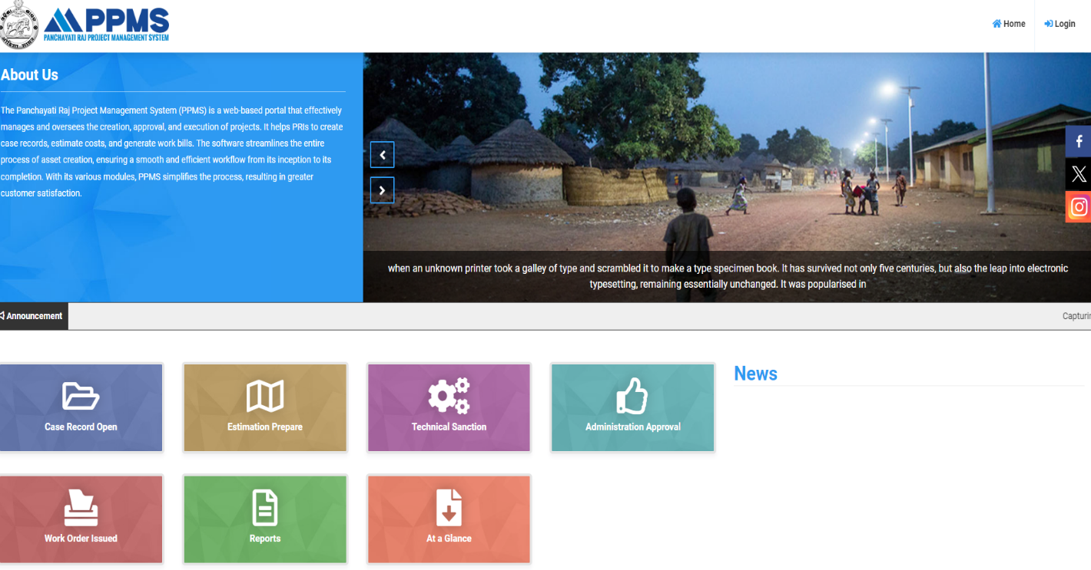

(Fig-01)
- After home page come out user need to click on Login as Fig-01

5.1 Dashboard

- After clicks on Sign in user will land to Dashboard page. (as Fig-02)
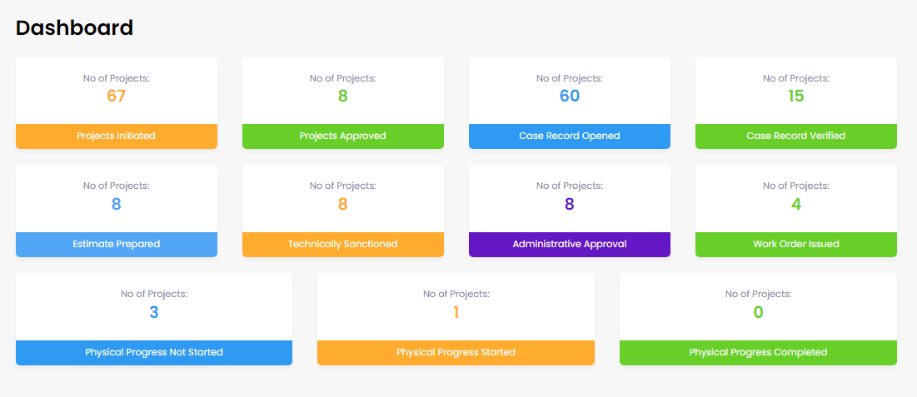

(Fig-02)
- Here user can see below details such as No of Projects Initiated, No of Projects Approved, No of Projects Case Record Opened, No of Projects Case Record Verified, No of Projects Estimate Prepared, No of Projects Technically Sanctioned, No of Projects Administrative Approval, No of Projects Work Order Issued and Geo tagging (Before, During, Complete).

- If someone click on Project Initiated, then the respective person will view the Project Initiated List. (as Fig-03)

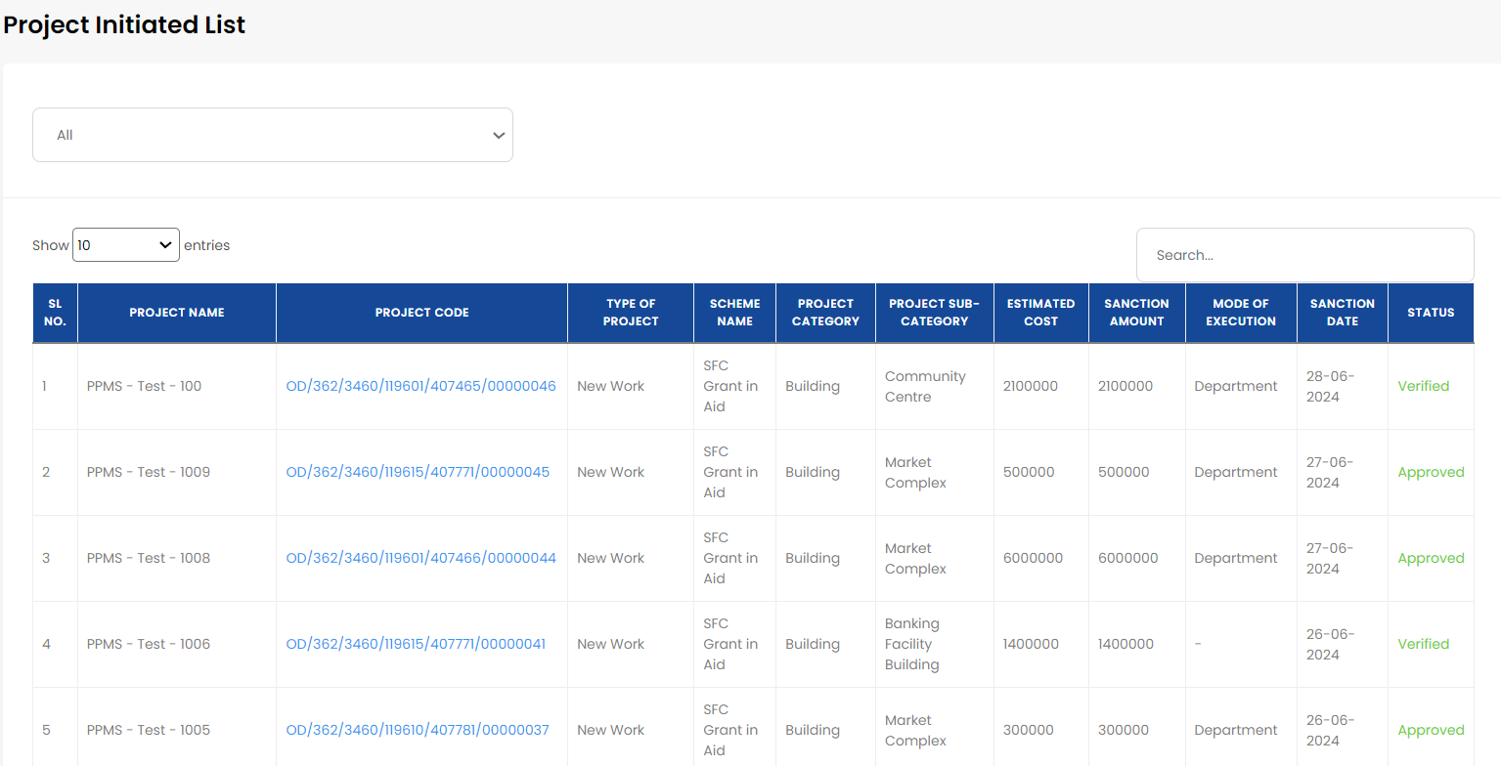
(Fig-03)
Likewise, user can see the details for below option
- No of Projects Initiated
- No of Projects Approved
- No of Projects Case Record Opened
- No of Projects Case Record Verified
- No of Projects Estimate Prepared
- No of Projects Technically Sanctioned
- No of Projects Administrative Approval
- No of Projects Work Order Issued
- No of Projects Physical Progress Not Started
- No of Projects Physical Progress Started
- No of Projects Physical Progress Completed

6 Process Flow
1-Project Creation
2-Open Case Record
3-Verify Case Record
4-Preparation of Estimation
5-Technical Sanction of Estimation
6-Administrative Approval of estimation
7- Generation of Work Order

8-Execution
9-Take Measurement
10- Prepare Bill

11-Check/test check Measurement
12-Verification of Bill
13-Approval of Bill
14-Disbursement of Payment
15-Asset Creation
PPMS Modules
1-Project Creation
District User
Block User
Upload Sanction Letter
2-Open Case Record
BDO User
DA User
Assign Development Assistant for case record preparation

Prepare the case record (Order sheet, Land report & upload supporting document

3-Verify Case Record
BDO User
Verify Case Record by verifying (Order sheet, Land report & upload supporting document)

Assign J.E for Estimation Preparation

State User

Estimation Engine
4-Preparation of Estimation
J.E User
Estimation Measurement

Add /Edit/Delete New Measurement

View Analysis

Copy existing Measurement Unit

Provide Carriage Details
- Provide Kilometer
- Select SoR Place
- Provide Additional Royalty Details with Royalty (Amount)

Estimation Abstract

Measured Quantity

Analysis Rate per unit

SoR Place
SoR Period
Manage Basic Rate
Manage Analysis Rate
Manage Miscellaneous Rate
Analysis wise Calculation
Manage Conveyance Rate
Manage Royalty Rate
Manage Convertible Unit
Assigned J.E selects Activity for Estimation Preparation

Concrete
R.C.C. Work
Reinforced Brick Work
Masonry Brick Work
Masonry Stone Work
Flooring
Painting
Plastering
Roofing
Wood Work
Road Work
Site Clearance
Dismantling
Other Building Items
Special items for irrigation works
Pile Foundation
Iron Work
Well Sinking
Bridge Works
Miscellaneous

Type of Work
Cell Calculation

Auto save Features

Unit Conversion

Admin need to activate the SoR Period for the current SoR date with all revised material rates
Master
Manage Specific Code Rate
- Number
- Length
- Breadth
- Depth
- CF

5-Technical Sanction of Estimation
J.E (0-3L)
A.E.E (3L<10L)
A.E.O (10L<1Cr)

S.E (1Cr<4Cr)
TS Authority does the Technical Sanction by checking the Estimation Measurement

6-Administrative Approval of Estimation
BDO (0-10L)
Chairperson PS (10L<20L)
Collector (20L<1Cr

State User (>1Cr)
AA Authority does the Administrative Approval by checking the Estimation Amount

7-Generation of Work Order
BDO
BDO will generate the work order
If the chair person doesn’t act within 7day, the system will automatically forward the file to BDO (10<20L)

8-Execution
J.E
J.E Upload geo tag photo before initiation, during execution and Completion photo through mobile application

9-Take Measurement
J.E
System fetches estimations measurement

User can perform the operation like Add, Edit, and Delete of Measurement

User provide MB Details

10-Prepare Bill
J.E
Capture Measurement Quantity

Capture Analysis Rate from abstract cost of Estimation

Provide Addition & deduction Component rate

Generate DPR
11-Check / Test check Measurement (<10L) (>10L)
A.E.E (<10L)
A.E.O (>10L)
Cross checked each individual Measurement

12-Verification of Bill
Head Clerk
Account Officer
13-Approval of Bill
BDO (0-2L)
Chair Person PS (>2L)
Approved Bill

14-Disbursement of payment
Cashier
Do payment through IFMS

7. Block User

- For web access, go to https://ppms.odisha.gov.in/, enter your credentials (Mobile Number and Password/OTP) to get into your account.
Click here for Login
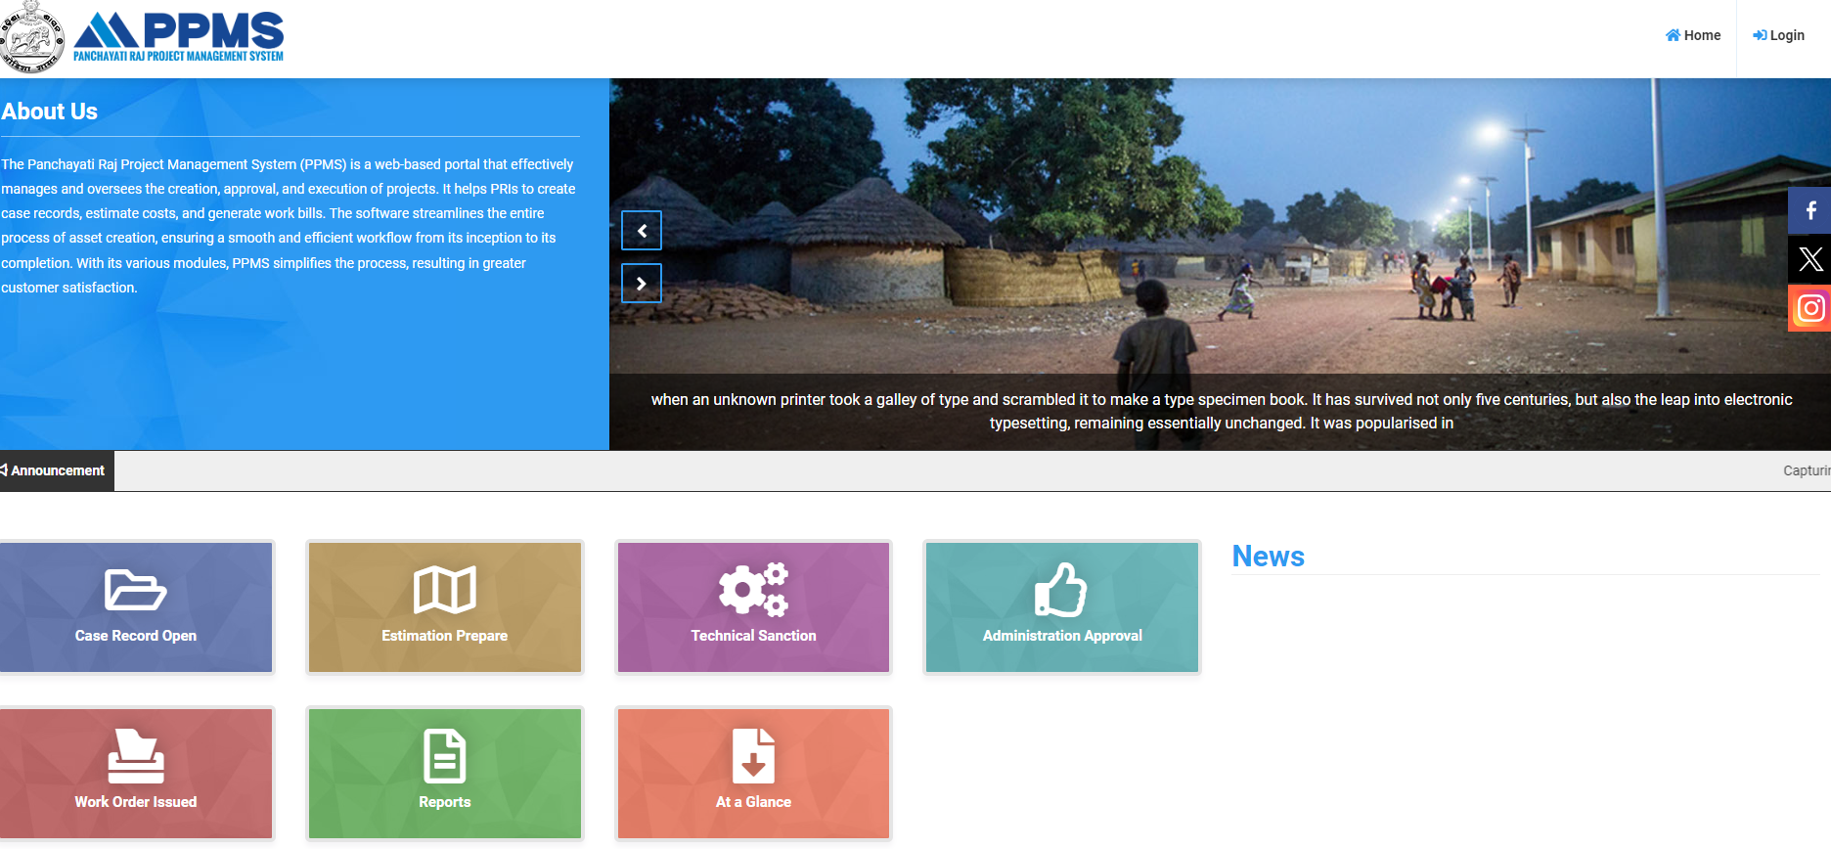

(Fig-04)

- After click on Login (as Fig-04), user need to do Sign in by entering the Mobile Number and Password/by using the OTP.
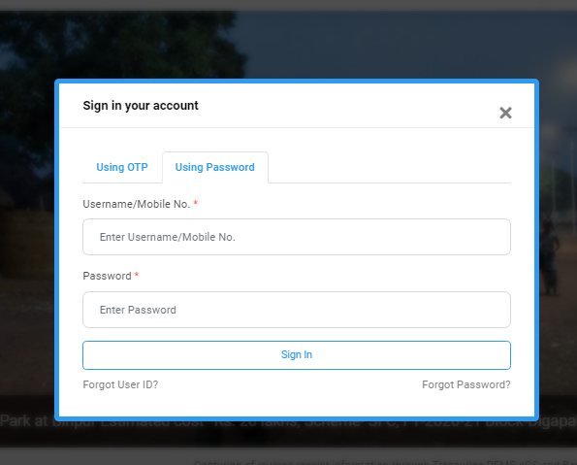

For OTP
For Password

1

2

3

(Fig-05)
- Marked 1: User need to put the Username.
- Marked 2: User need to put the Password. (As Fig-05)
- Marked 3: Click on Sign in for entering into the account.

- For OTP Login (As Fig-06) follow below instructions:

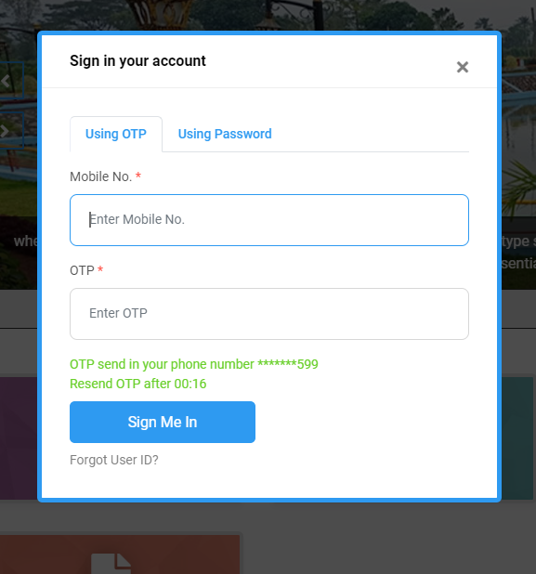

1
3
2

(As Fig-06)

- Marked 1: User need to put the Mobile No.
- Marked 2: User need to put OTP.
- Marked 3: Click on Sign in for entering into the account.

- After entering to the account Block User redirect to the Dashboard (As Fig-07) page.

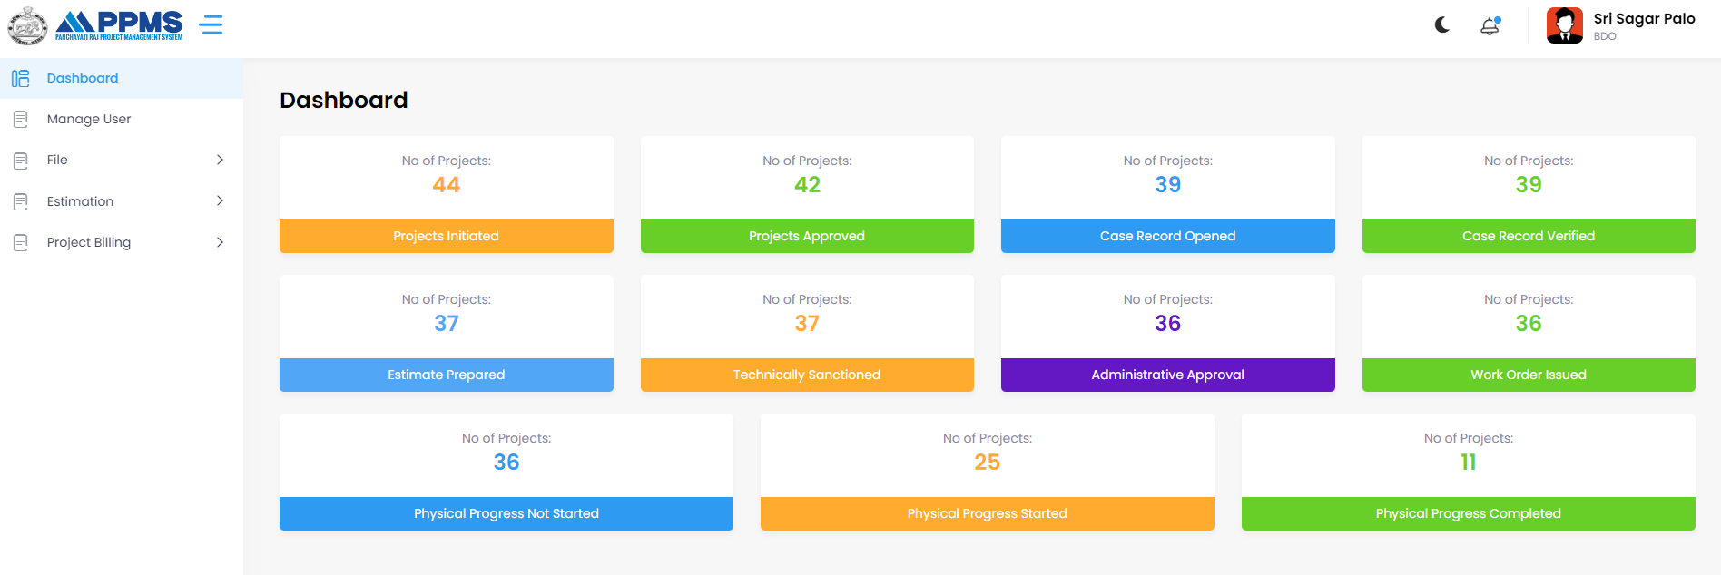

(Fig-07)

- When user click on each option, they can able to view the project lists that are Initiated, Approved, Case Record Opened, Case Record Verified and able to know the status of the projects.

- If user click on Project Initiated, (As Fig-08) user can able to see the projects lists like below:

User can able to see the lists like this for rest of the options present in Dashboard

(Fig-08)

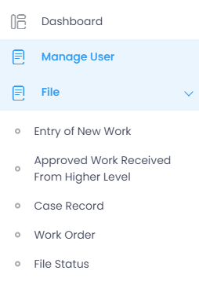
7.1 BDO responsible for Entry New Project
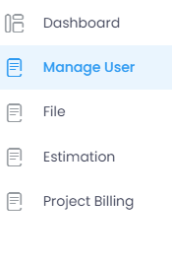
Click on File

Entry of New Work allow user to add new project

(Fig-09) (Fig-09-A)

- After clicking File (As Fig-9), its showing Entry of New Work (As Fig-09-A).
- After clicking Entry of New Work (As Fig-09-A), it’s now asking user to add new project (As Fig-09-B).

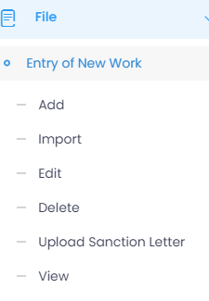
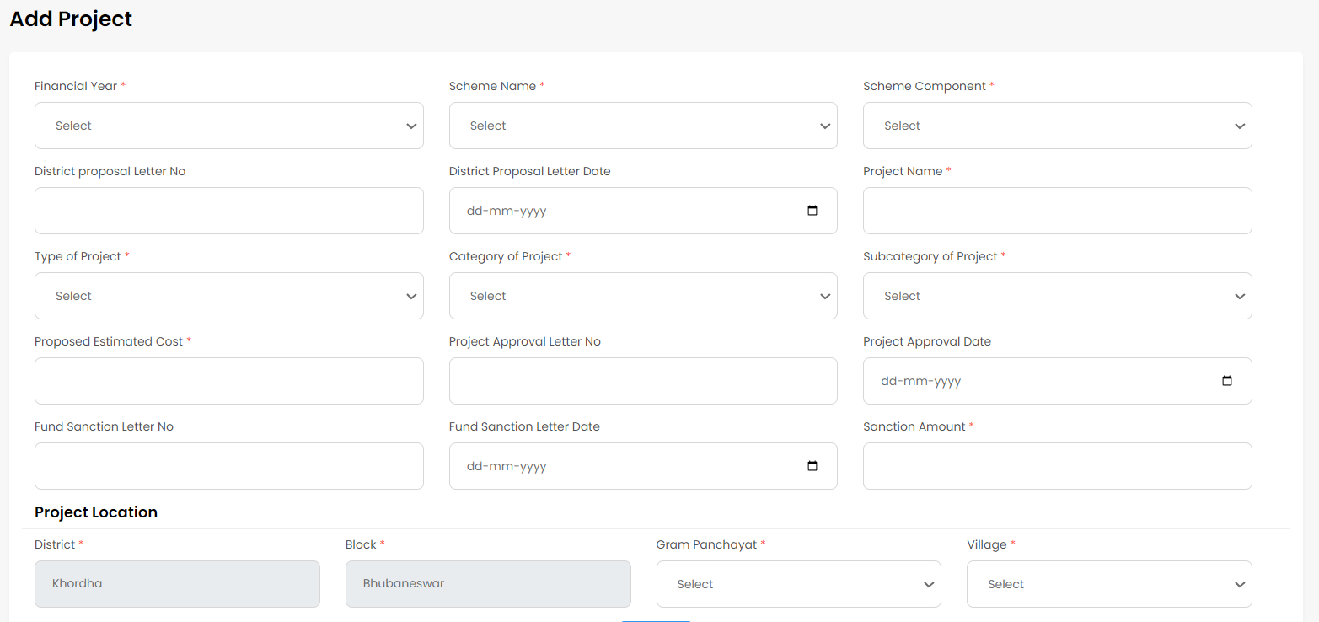

(Fig-09-B)
- Now user can add new project by providing the necessary details. (Fig-09-B).

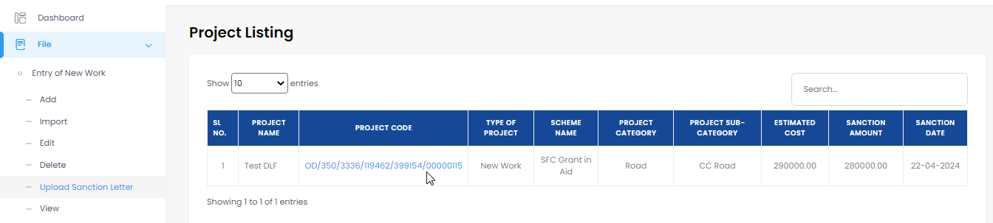

Project code
(Fig-10)
- New project created that user can see under Project Listing. (As Fig-10).
- Click on the project code to view (As Fig-11).

7.2 For Uploading Sanction Letter:

- User needs to follow below steps for uploading the Sanction Letter. (As Fig-11).

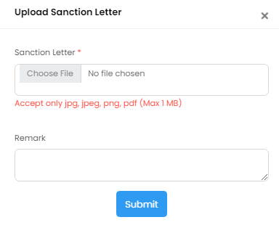

(Fig-11) (Fig-11-A)

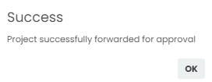

(Fig-11-B)

- User upload sanction letter (As Fig-11-A), BDO user also have provision to provide Remark in Remark section as shown (As Fig-11-B).
- After clicks on submit it successfully forwarded as shown (As Fig-11-B).

7.3 BDO User- Assign Developmental Assistant for case record Preparation

- Now BDO User can assign DA for preparing case record by following below steps. File -> Approved Work Received from Higher Level -> View (As Fig-12-A).

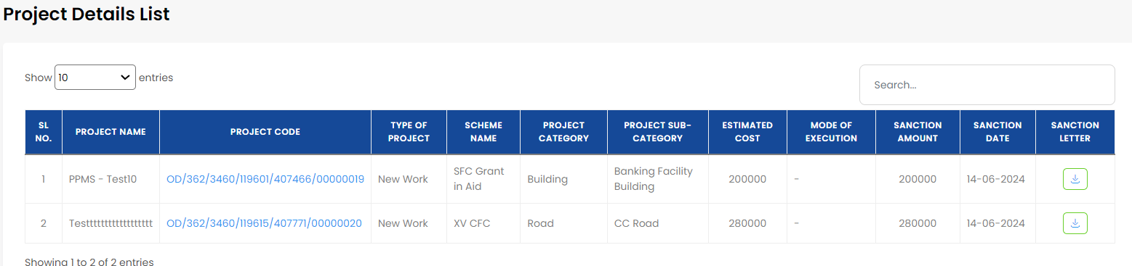
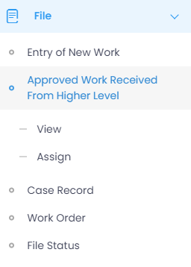
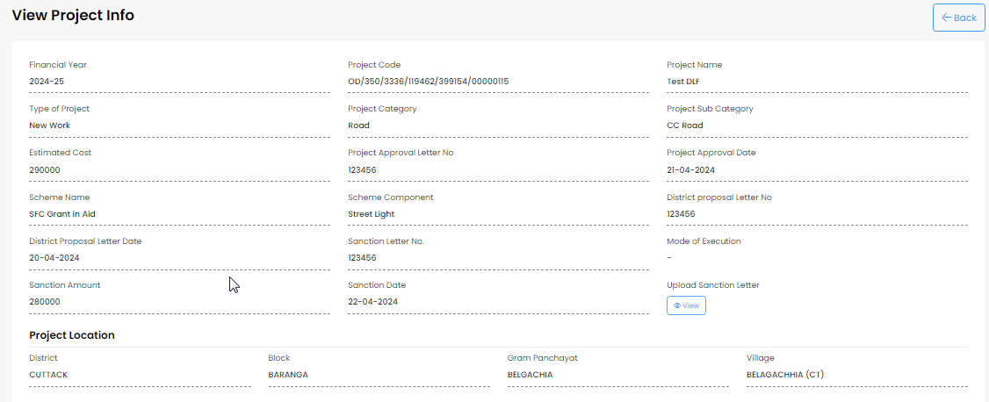
(Fig-12-A) (Fig-12-B)

(Fig-12-C)

- User need to click on Approved Work Received from Higher Level, below that View option enables user to see the Project Details List as (As Fig-12-B).
- After that user able to View created Project Info as shown (As Fig-12-C).
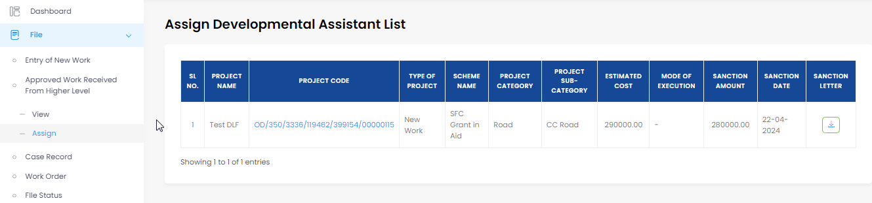

(Fig-12-D) (Fig-12-E)

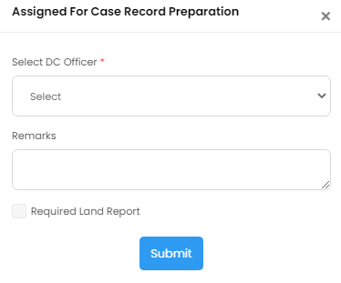

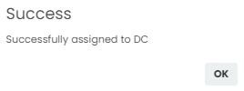

(Fig-12-F) (Fig-12-G)

- User clicks on assign (As Fig-12-D) to view assign developmental assistant list. If user will click on the Project details (As Fig-12-E) Button, which will lead to open assigned for case record preparation (As Fig-12-F). Here select DA officer for assign. And clicks on submit button.

- After successful completion a pop up will be displayed as shown (As Fig-12-G).

8. DA User- Prepare case record (Land Report)

- DA user can prepare the land report by following,

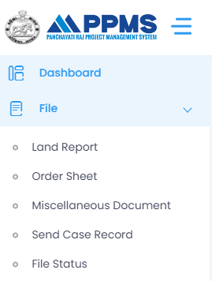
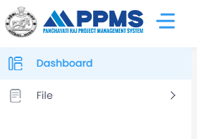
(Fig-13-A) (Fig-13-B)
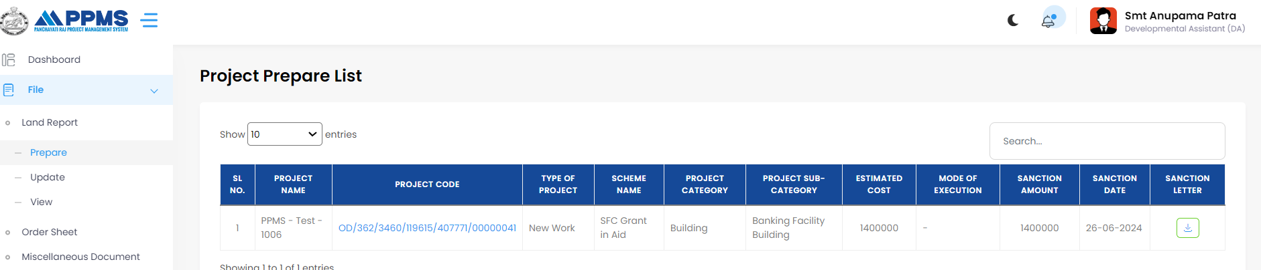

Click on Prepare

Click on that to Generate Project Land Report
Click here to Prepare
- After clicking on Land report, that’s showing prepare.
- If we click on prepare, Project code will display.
- After click on project code, Generate Project Land Report will display.

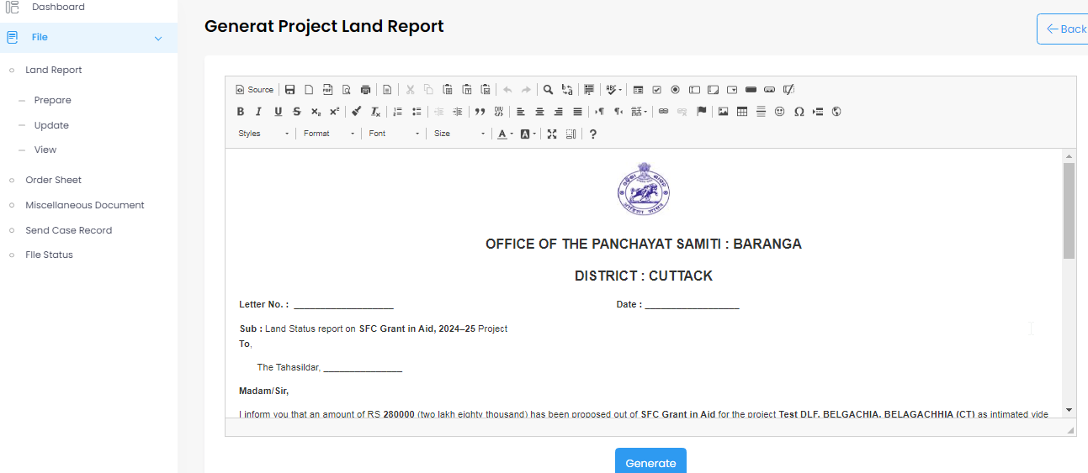

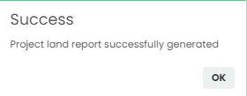

Click here to Generate

(Fig-13-C) (Fig-13-D)

- After clicking on generate button it will show project land report successfully generate as shown in the picture. (As Fig-13-D).

8.1 DA User- Prepare case record (Order Sheet)

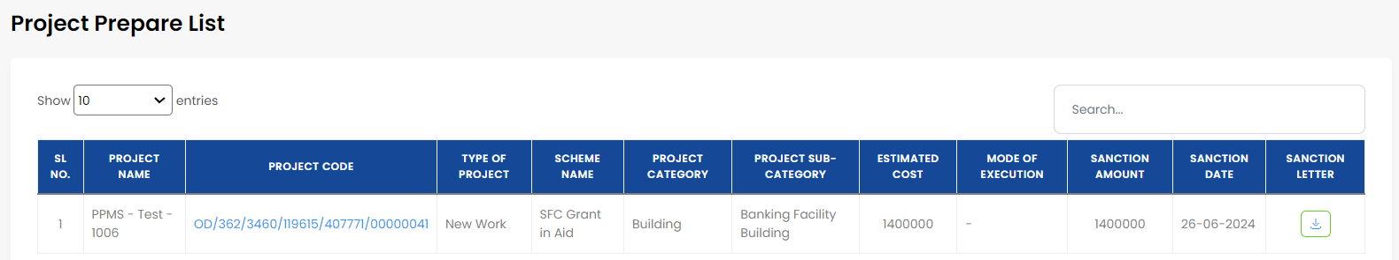
- DA user can prepare the order sheet by following.
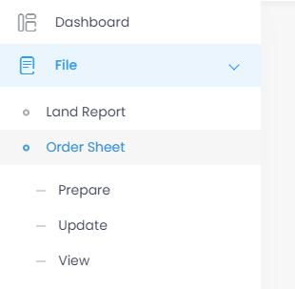
(Fig-14-A) (Fig-14-B)
Click on File -> Order Sheet -> Prepare

- After getting Project Prepare List user need to click on Project Code shown (As Fig-14-B) to get the Prepare Order Sheet shown (As Fig-14-C).
Editable
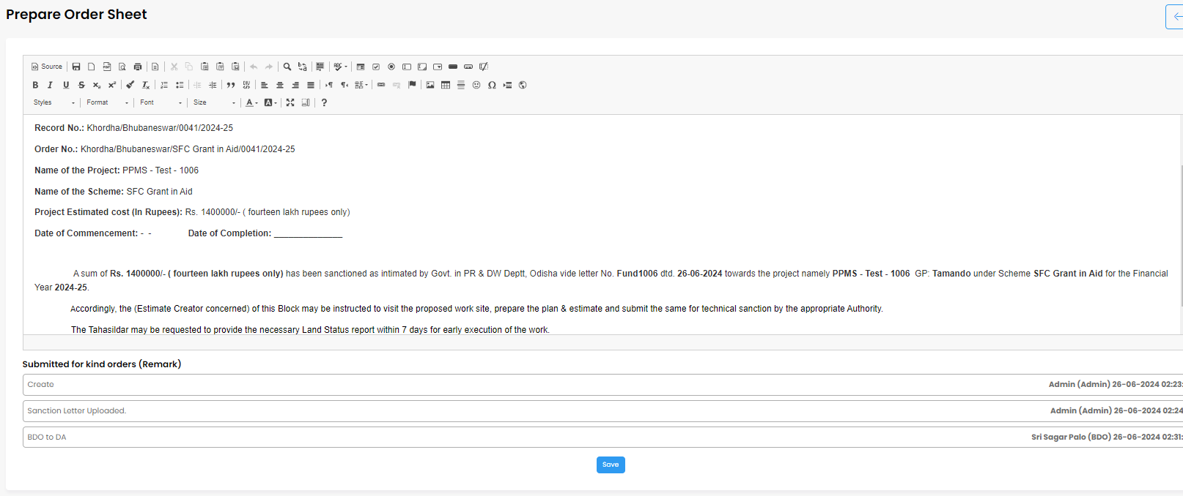
Click on Save button
(Fig-14-C)
- Users are able to edit the Prepare Order Sheet if they so choose.
- Now user need to click on Save (As Fig-14-C) which will lead to Prepare Order Sheet added successfully that shown (As Fig-14-D).

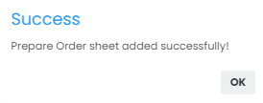

(Fig-14-D)

8.2 DA User- Prepare case record (Upload Supporting Document)

- DA user can prepare the Miscellaneous Document by following,
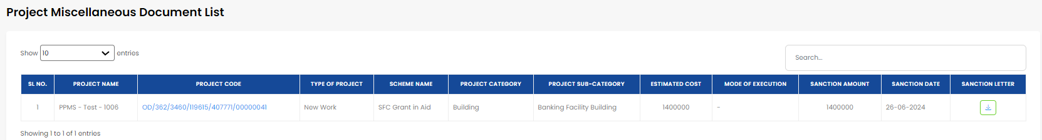
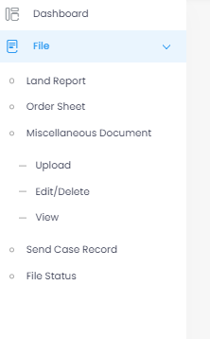
User need to click on Upload to get Project Miscellaneous List as (Fig-15-B)
(Fig-15-A) (Fig-15-B)
- After selecting Miscellaneous Document, the DA user clicks Upload (As Fig-15-A).
- After clicking "Upload," the project code will appear.
- Now, click on Project Code shown (As Fig-15-B) which open a new page allow user to Upload Project Document.

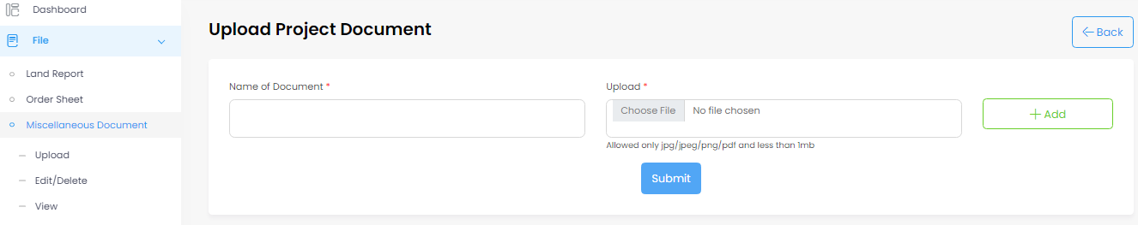

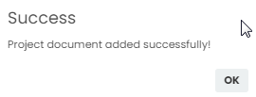

(Fig-15-C) (Fig-15-D)

- User can Choose File to upload and able to Add also.
- After clicking user able to added Project document successfully as shown (Fig-15-D).
- User can edit and delete the document. (Fig-15-C).

8.3 DA User- Forward case record to BDO
- DA user can forward by following,
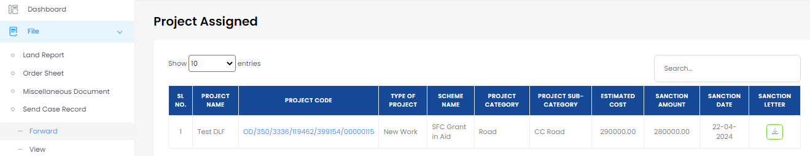

Click on Project Code
User need to click on Send Case Record
(Fig-16-A)
Click on Forward

- The user must click Send Case Record (As Fig-16-A) before they can see the Forward button, which displays Project Assigned. Clicking the Project Code to view Forward pop up(As-Fig-16-B).

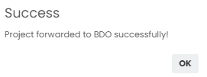
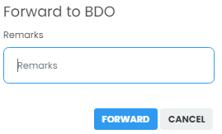
(Fig-16-B) (Fig-16-C)

- User can write Remarks after that need to click on FORWARD, so that Project forwarded to BDO successfully. (As Fig-16-B).

Editable

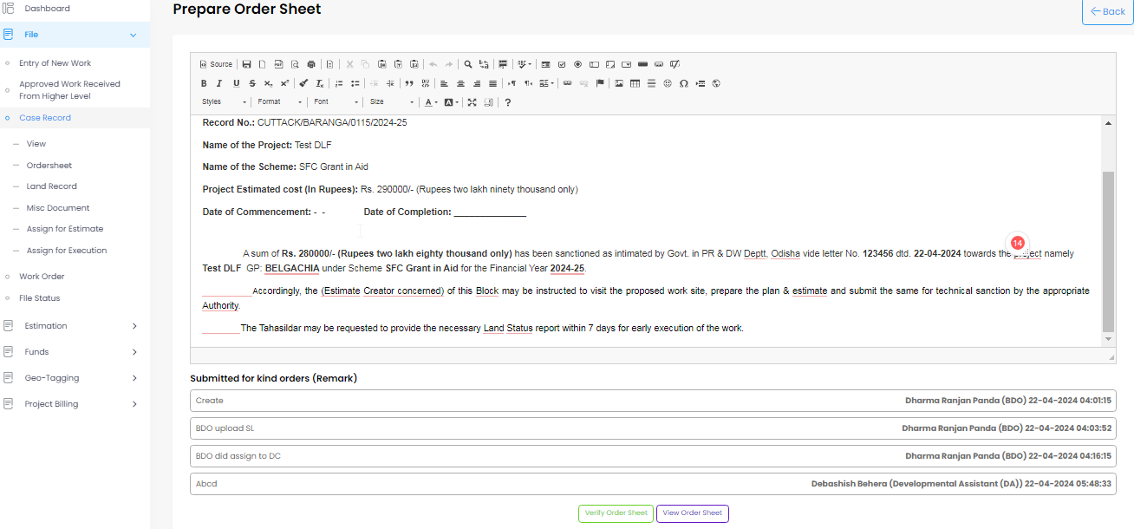
9. BDO User- Verify Case Record (Order Sheet)
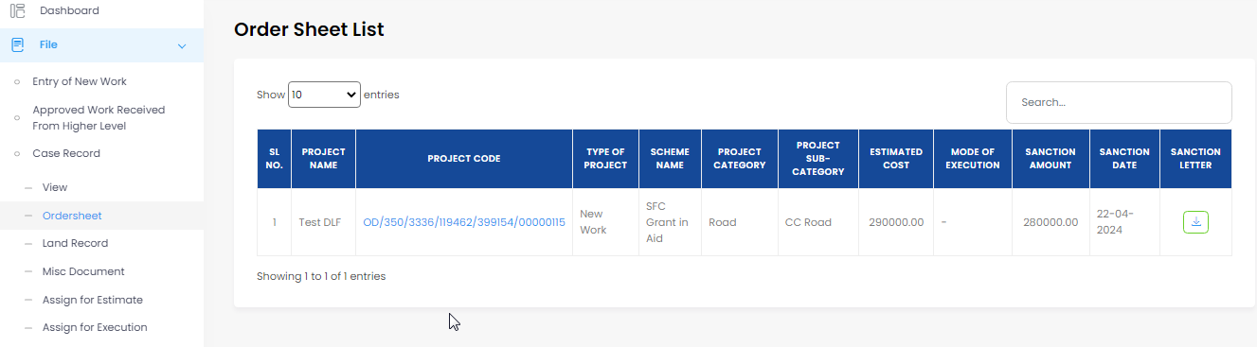

Click on it which will open Order Sheet
(Fig-17-A) (Fig-17-B)
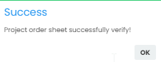
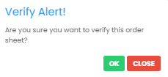
(Fig-17-C) (Fig-17-D)
- If user clicks on order sheet(Fig-17-A), user will see the order sheet list.
- If user will click on the project code, which will lead to open (Fig-17-B) new page, if clicks on verify order sheet it will be show verify alert pop up. (Fig-17-C).
- If you click on ok, it will be showing project order sheet successfully verify. (Fig-17-D).
Editable

9.1 BDO User Verify Land Report:
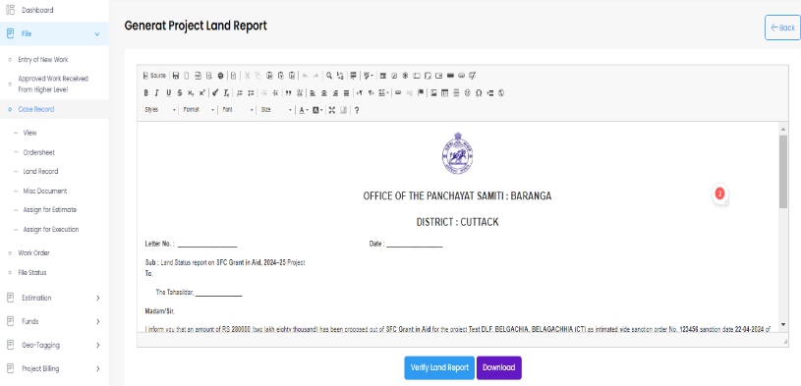
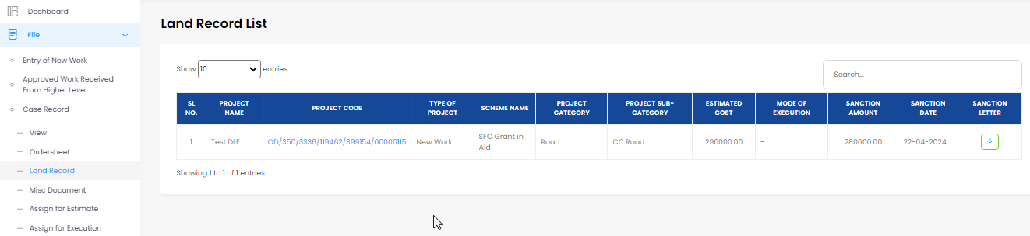
Verify Land Report

(Fig-18-A) (Fig-18-B)

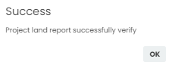
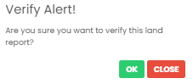

(Fig-18-C) (Fig-18-D)

- If user clicks on land record, user will see the land record list. (Fig-18-A).
- If user will click on the project code (Fig-18-A), which will lead to open new page(Fig-18-B), if clicks on verify land report it will be show verify alert pop up as shown (Fig-18-C).
- If you click on ok, it will be showing project land report successfully verify as shown (Fig-18-D).

9.2 BDO User- Verify Case Record (View Supporting Document)
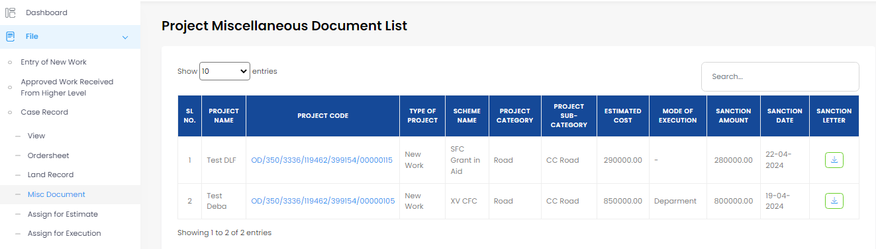
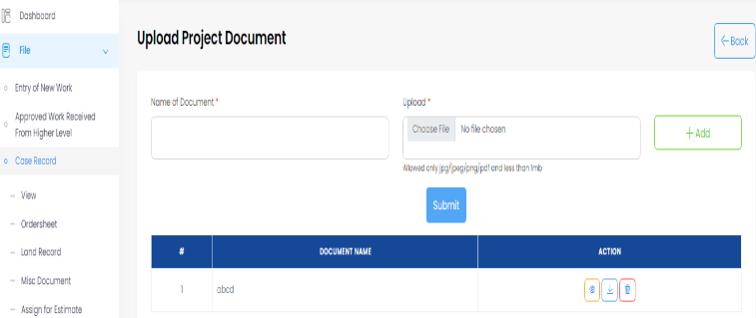

Project Code
(Fig-19-A) (Fig-19-B)
Click here to add
Click on Misc. Document
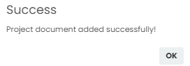
(Fig-19-C)

- User need to click on Misc. Document to view the Project Miscellaneous Document List. (Fig-19-A).
- After that user need to click on project code (Fig-19-A) to upload project document as shown (Fig-19-B).
- Successfully clicking on Submit there a new notification come out as Project document added successfully as shown(Fig-19-C).

9.3 BDO User- Assign Work Estimate J.E
- BDO user can assign work for Estimate.
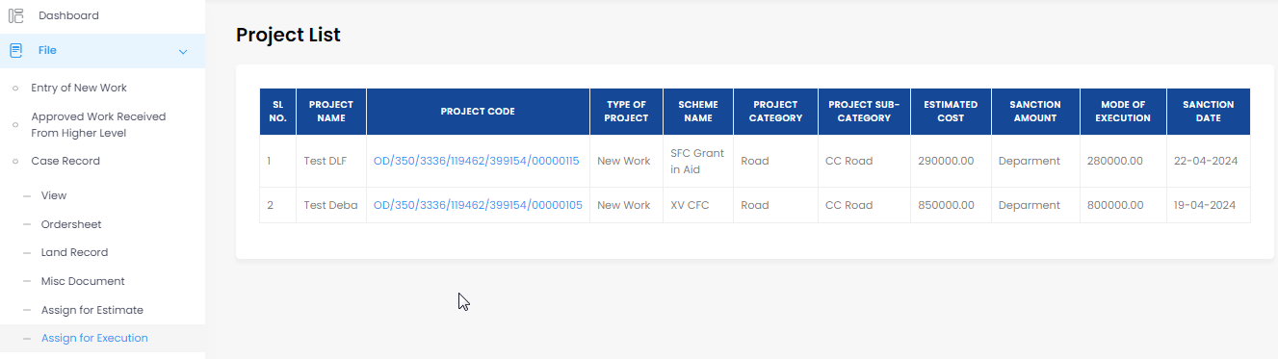
(Fig-20-A)
Click on Assign for Estimate

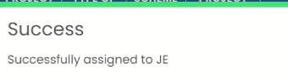
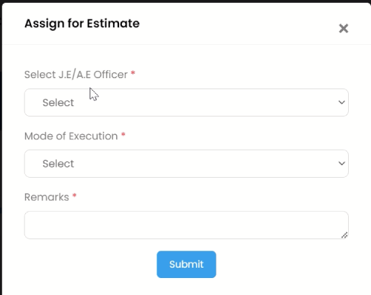
Departmental

(Fig-20-B) (Fig-20-C)

- When user click on Assign for Estimate (As Fig-20-A), it redirects to project list. When user click on respective Project Code (Fig-20-B) it allows user to Estimate.
- After clicking on Submit It Successfully assigned to JE as shown in the picture No.3(Fig-20-C).

10. J.E User- Prepare Estimate

- Can be done in following ways,
Click on Estimation
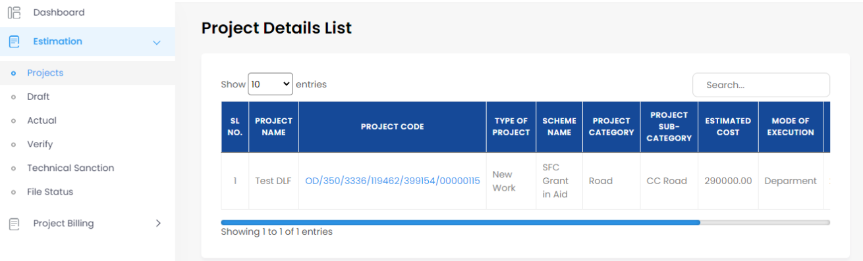

Click on Projects

Click on the project Code

(Fig-21-A)

- User need to click on Estimation, below click on Projects to view.
- The Project Details List should appear when the user clicks on Projects.
- After that click on Project detail code page will come as shown below.

1-Enter Proposed Duration to Complete the Work
2-Enter Expected Outcome
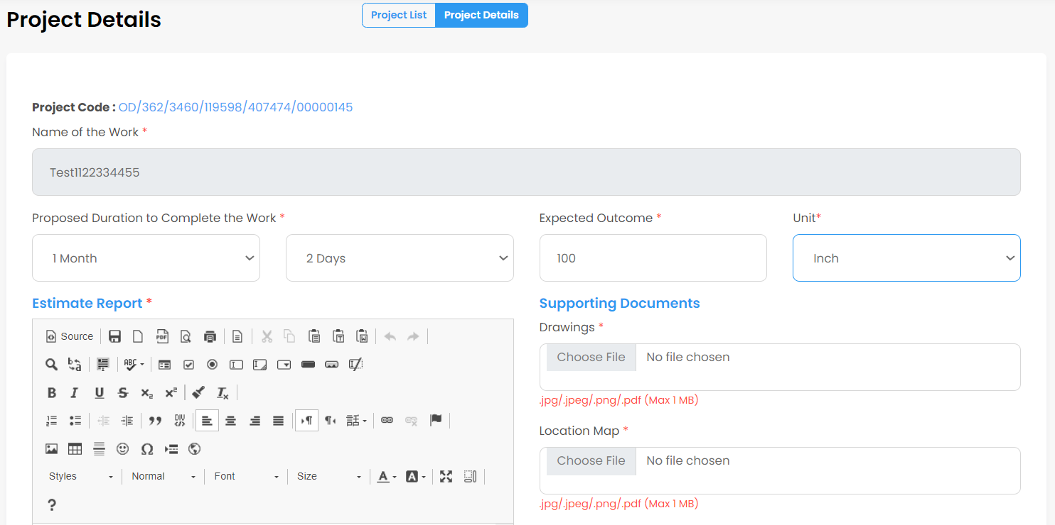
3-Choose the required Unit from the Dropdown
f
4-Upload Drawings as jpg/jpeg/png/pdf (Max 1 MB)

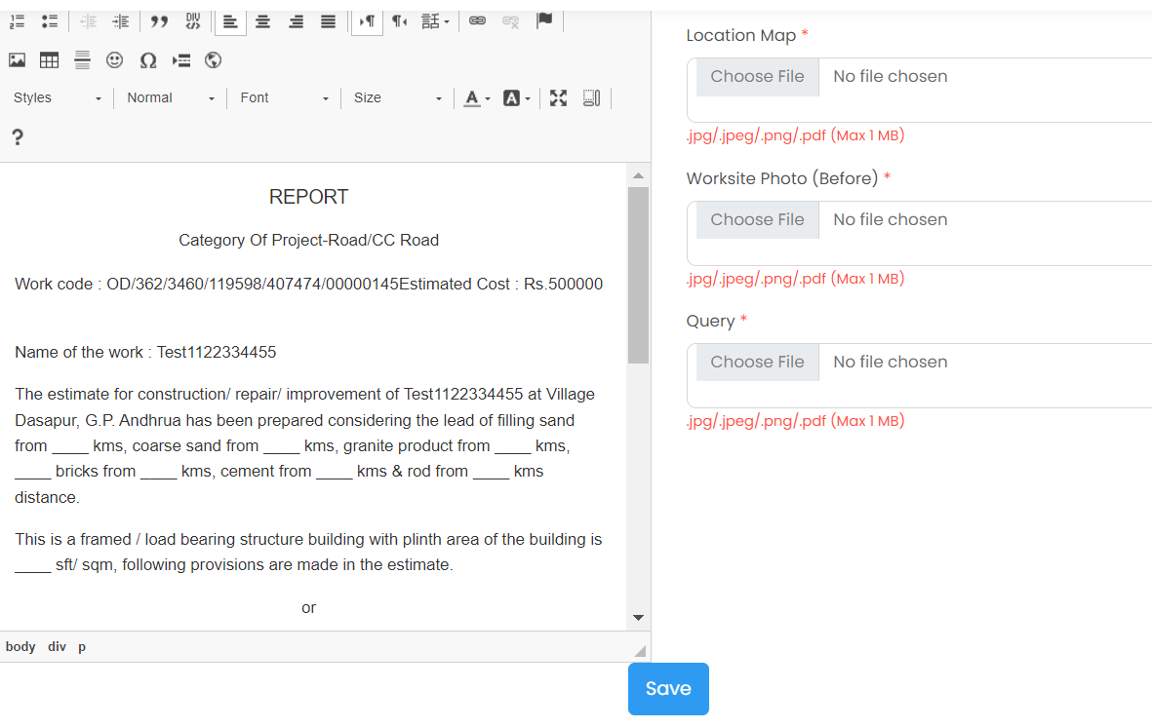
5-Upload Location Map as jpg/jpeg/png/pdf (Max 1 MB)

6-Upload Worksite Photo (Before) as jpg/jpeg/png/pdf (Max 1 MB)

7-Upload Query as jpg/jpeg/png/pdf (Max 1 MB)

8-Edit based on user requirements

9-Here you can save it

(Fig-21-B)

- The Work's Proposed Duration (1) can be entered by the user.
- The User can enter an expected Outcome (2).
- The user can select the necessary unit (3) from the dropdown menu.
- User need to upload all the required Supporting Documents Drawing (4), location map (5), worksite photo (6) and Query (7) to proceed.
- The report (8) can be edited by the user according to their needs.
- When user click on Save (9) on Project Details tab it automatically forward to Prepare Estimate tab.
E

View specific rates

Prepare the estimate

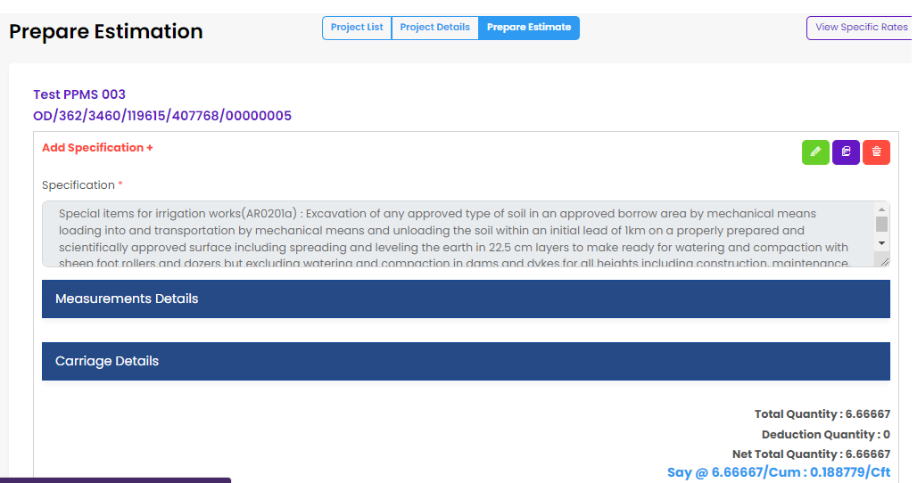
10.1 J. E User- Prepare Estimate
A B C

1-Edit
2-Duplicate
3-Delete

D

(Fig-22-A)
- The estimate can be prepared (C) by the user.
- The user can view all measurement by clicking on specific rates(D).
- The items can be edited and deleted (E) by the user.
- The user can copy the measurement (E)
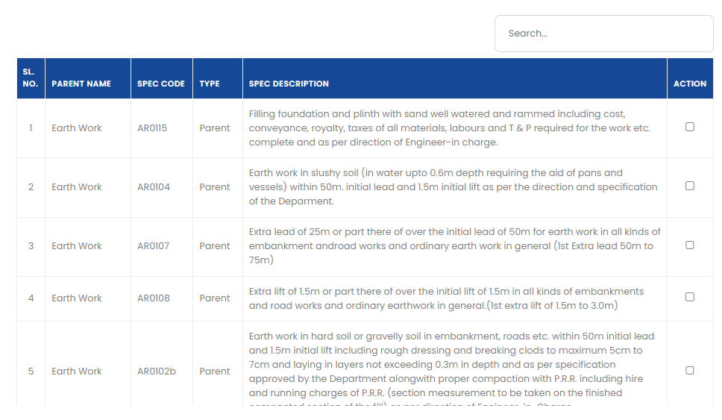
(Fig-22-B)
Check box

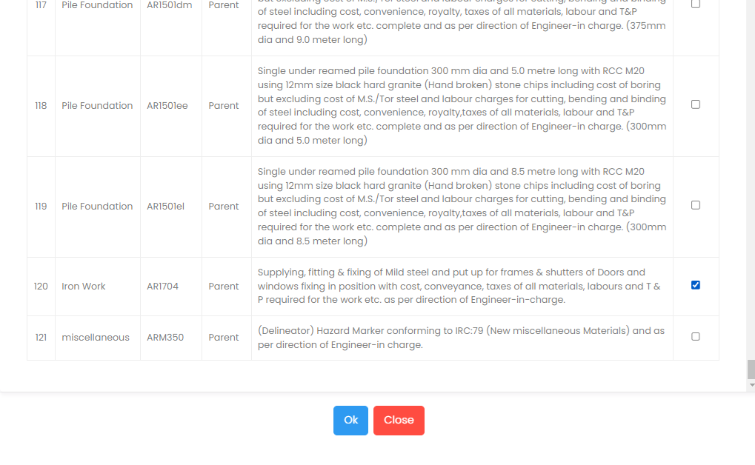
- The user has the option to either select or search the items.
(Fig-22-C)
Ok Button
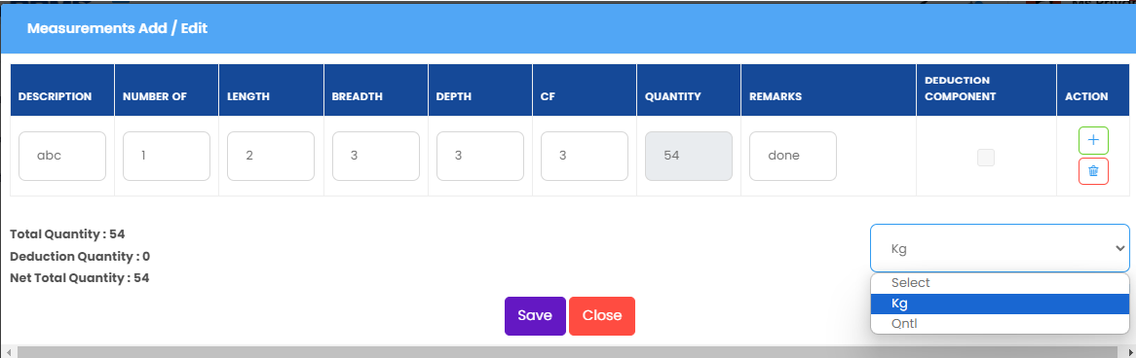
- The user has the option to check the box and click "OK."
Delete measurement

Add measurement

Unit section

(Fig-22-D)

- Fill out all the necessary fields like Description, length, breath, depth and CF.
- User can add measurement and delete measurement.
- And choose the unit from the drop-down menu before saving it.

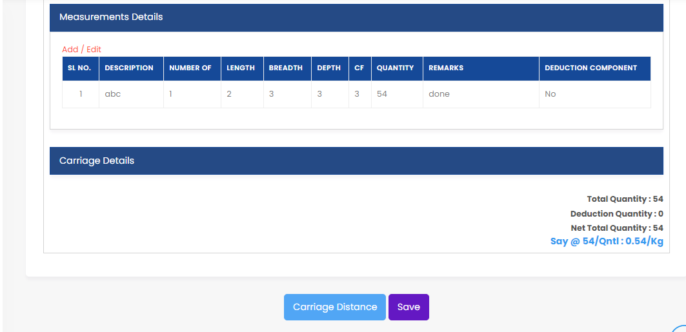

(Fig-22-E)
Save

Carriage distance

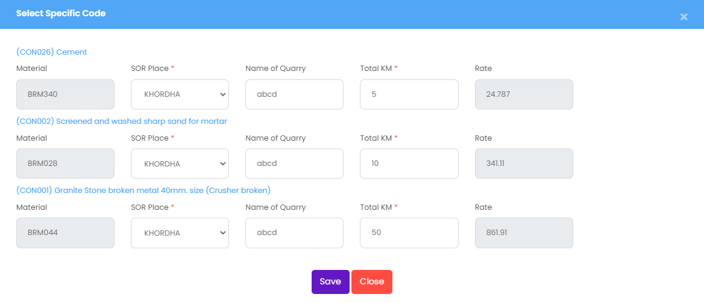

Save

(Fig-22-F)
- The user must click on the carriage distance (As Fig-22-E) button to display the (As Fig-22-F).
- Quarries and KM can be entered by the user and saved.

10.2 J. E User- Make Abstract

- Abstract can be done in following ways,
Make Abstract

DPR

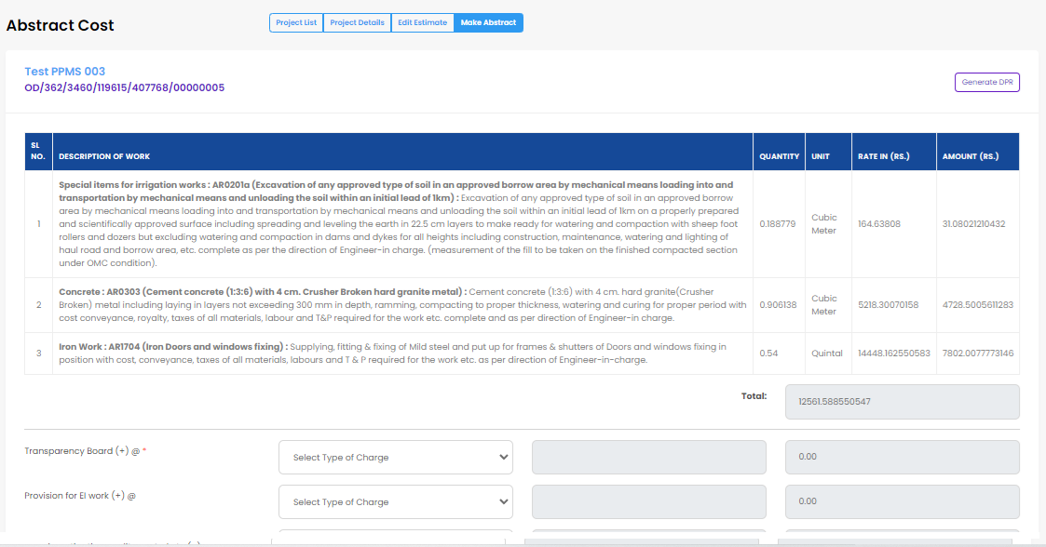
User can select lump sum or percentage

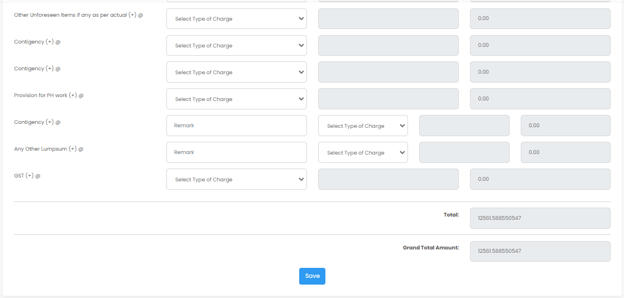
Total amount display here

Save

(Fig-23-A)
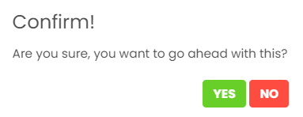

(Fig-23-B)
- When a user clicks DPR, the Details Project Report is displayed.
- Lump sum or percentage can be chosen by the user to control the estimated balance.
- Once everything is filled out, save (As Fig-23-A) it.
- When we save it, a confirmation window will appear; if you select "yes," (As Fig-23-B) it will be stored.

10.3 Verify the estimation:

- User need to click on Estimation > Verify > View

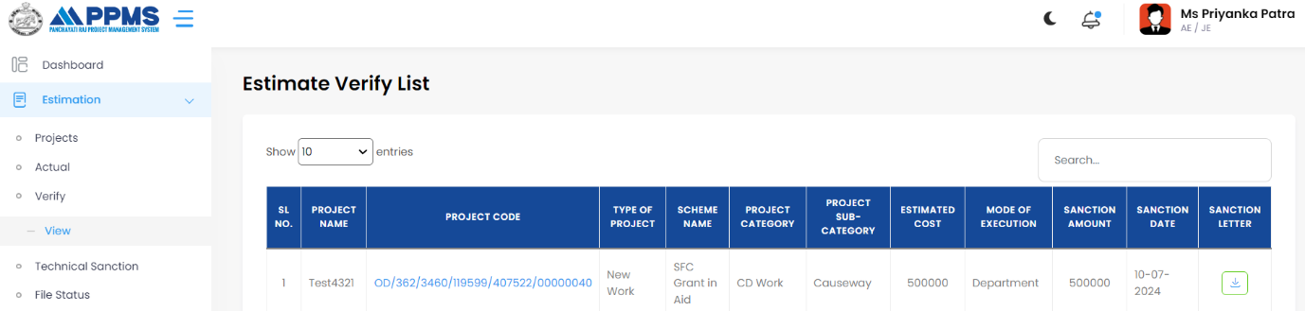

(Fig-24-A)
Click here to Verify

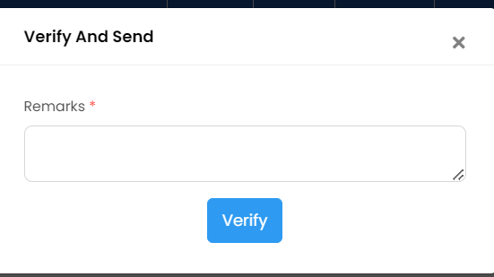

(Fig-24-B)
- Now after putting the Remarks, user can Verify. (As Fig-24-B).
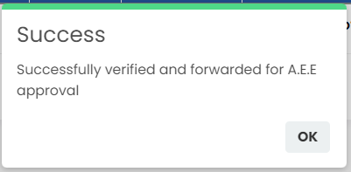

(Fig-24-C)

- Now it’s Successfully verified and forwarded for A.E.E approval (As Fig-24-C).

10.4 TSA User- Technical Sanction

- Now Technical Sanction Authority user does the Technical Sanction.
Criteria for Technical Sanction:
Amount User
0-3L JE
3-10L AEE
10-50L AEO
50L-more SE
- Here, the project amount is 5L, so now AEE responsible for Technical Sanction.

AEE user
- Before going to technical sanction AEE have authority to Revert the Estimation.
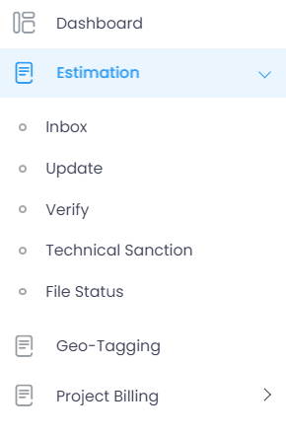(Fig-25-A)
Now AEE user click on Estimation then below that Inbox so click on that
- When you click on the estimation, the Project Details List should appear if you click on the inbox.
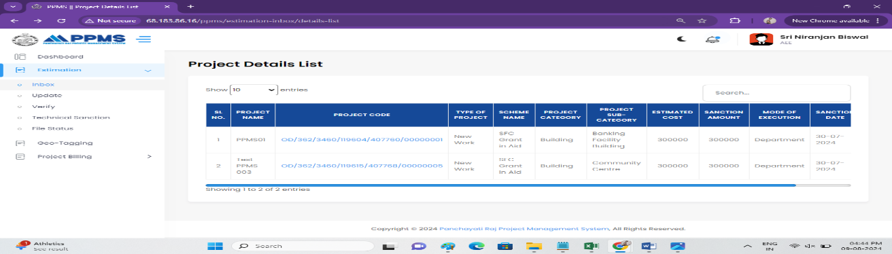
(Fig-25-B)
Project Details Code

- After that you can see the Project Detailed Code (Fig-25-B) so click on the respective project.

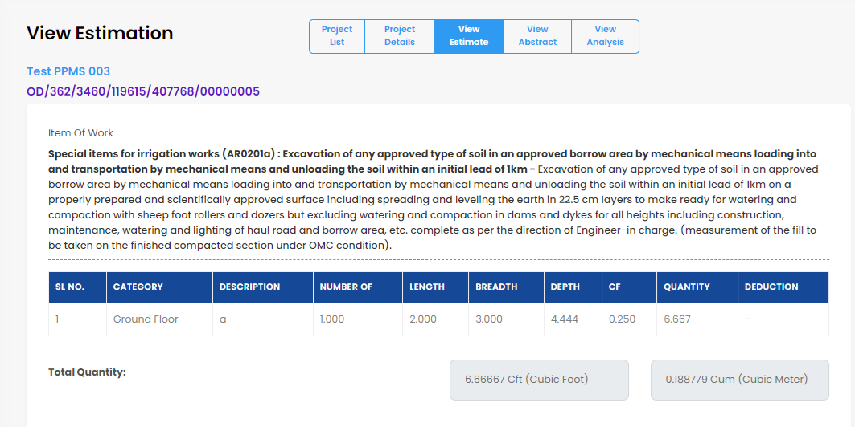

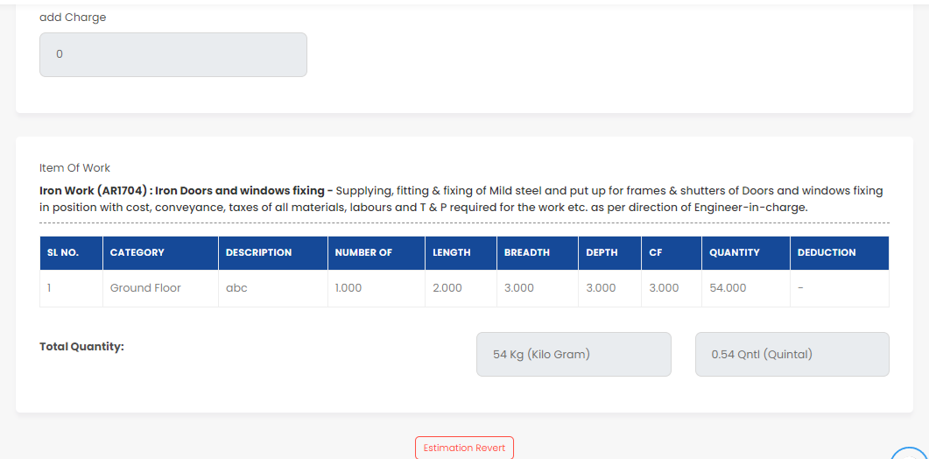

(Fig-25-C)
Revert
- Users have the option to revert (Fig-25-C) the estimation if they so want.
Click on View Estimate
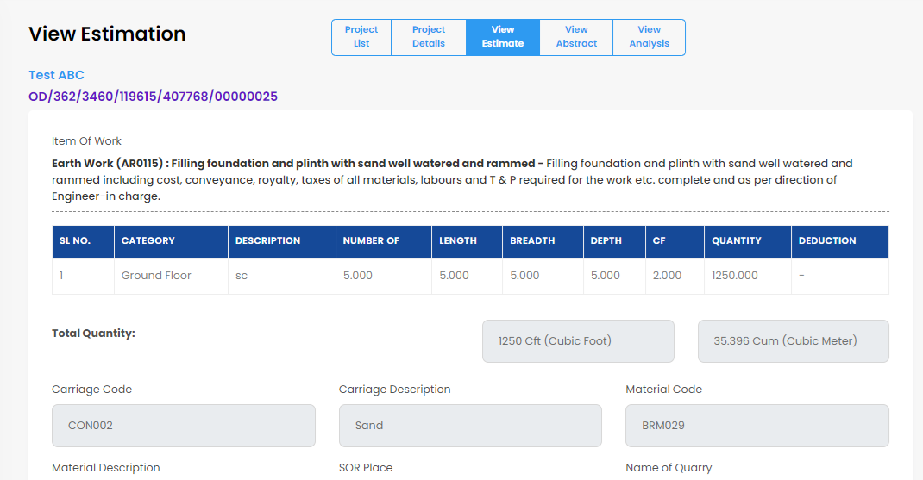
(Fig-25-D)
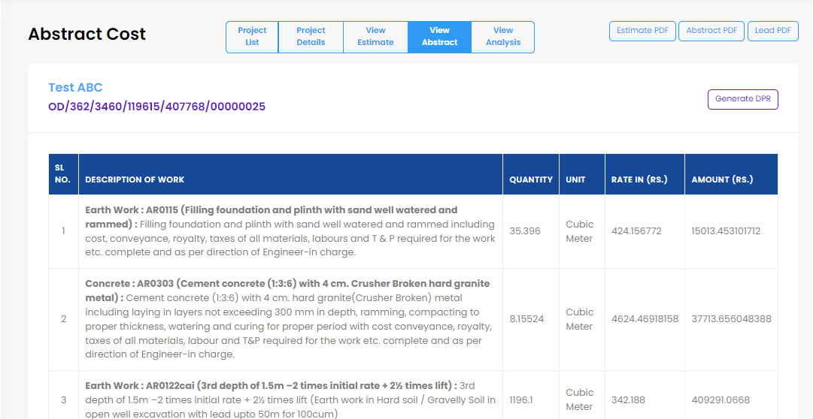
- User can view the estimate.
Click on View Abstract
(Fig-25-E)
- User can view the Abstract.
Click on View Analysis
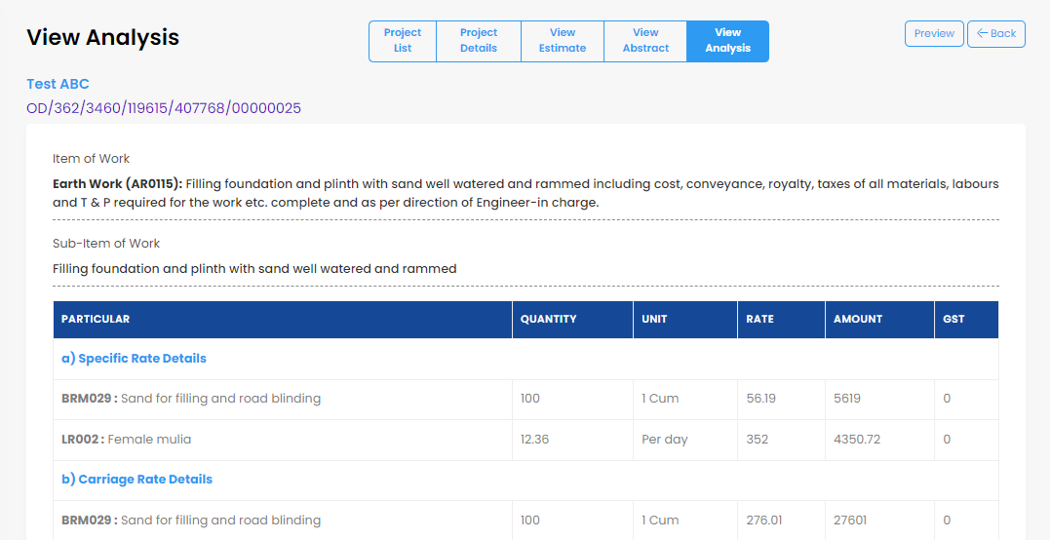
(Fig-25-F)

- User can view the Analysis.
Estimate revert: -
Click on View Estimate
(Fig-25-F)
Click here for revert

- By clicking on Inbox user able to see Project Details Code (Fig-25-A) by following.
- The Estimate Revert (Fig-25-F) will be displayed whenever the user clicks on the Project Details Code.
- The project will be reverted when the user clicks on Estimate Revert.

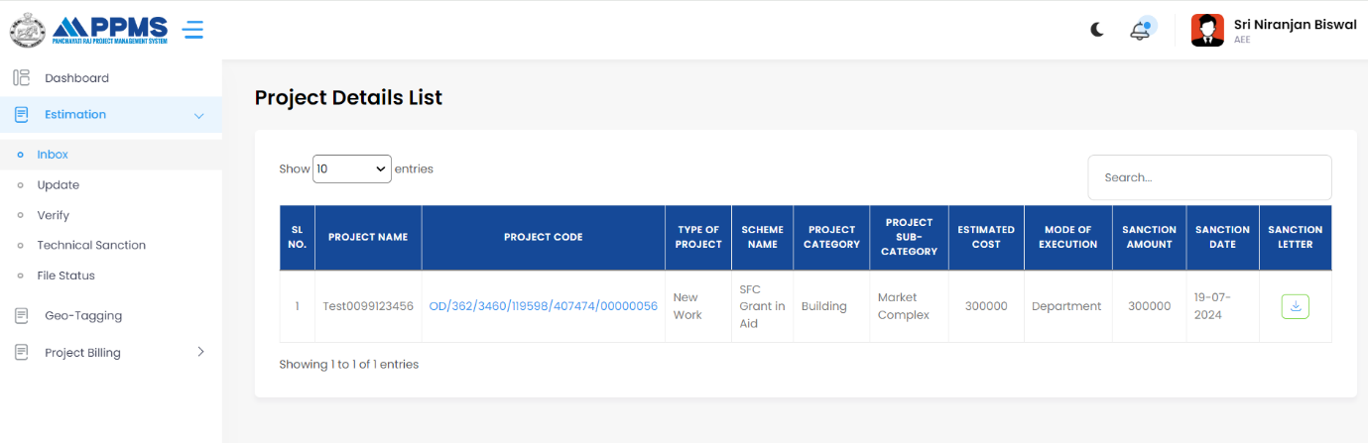
- Click on Estimation

3. Click on Project Code
2. Click on Inbox to view the Project Details List

(Fig-26-A)

- Now user will see the below screen after clicking on Project Code(Fig-26-A).
User can see Project Details, Estimate, Abstract and able to View Analysis
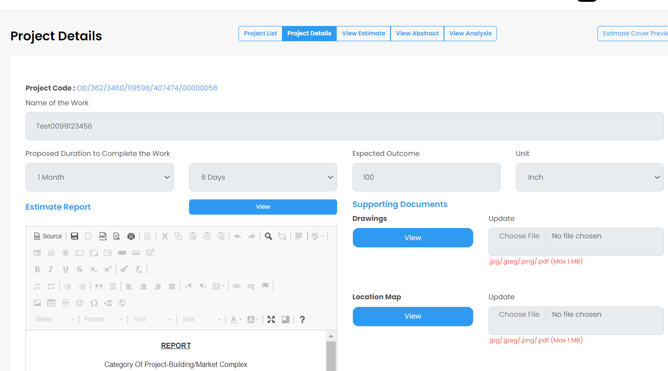
By clicking on View user able to view all the uploaded supporting documents

(Fig-26-B)
- Here user view project details after clicking on Project Details tab now user will click on View Estimate(Fig-26-B),

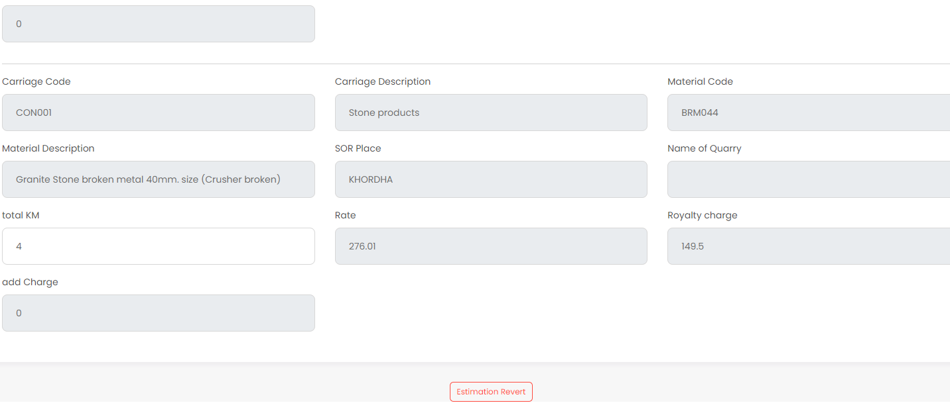
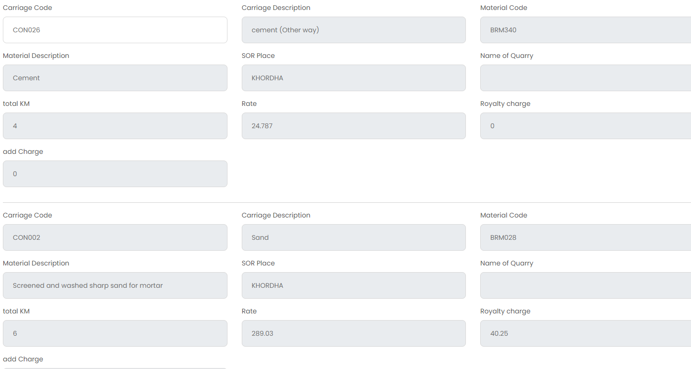
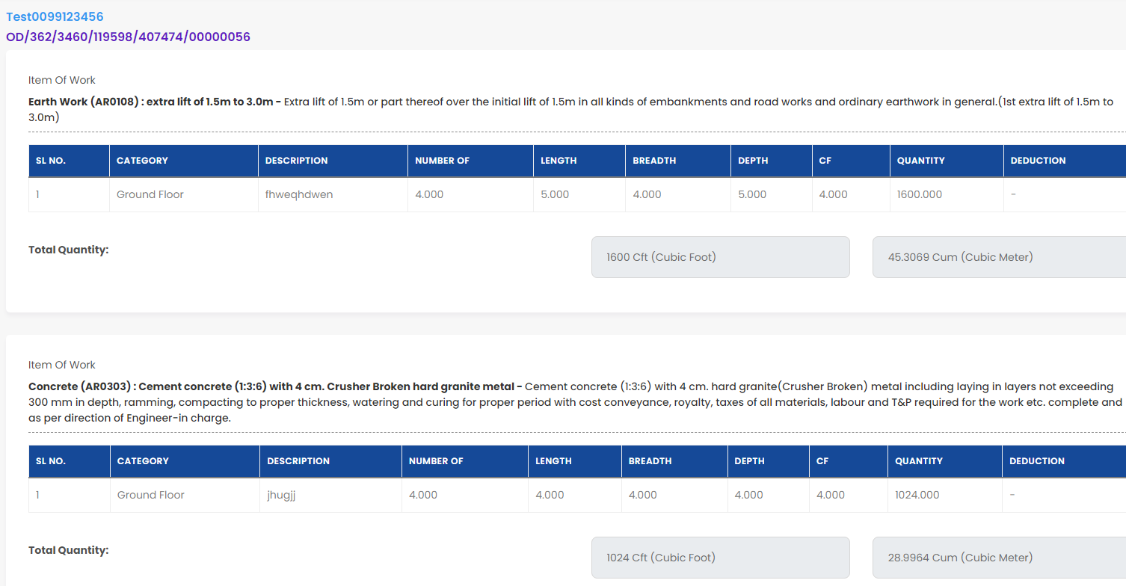
Here user can view Item of Work
User can revert the estimation here
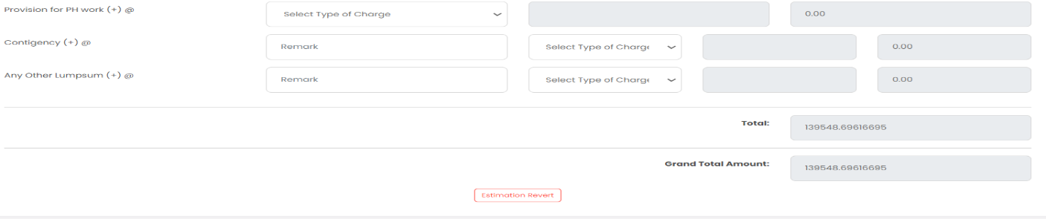
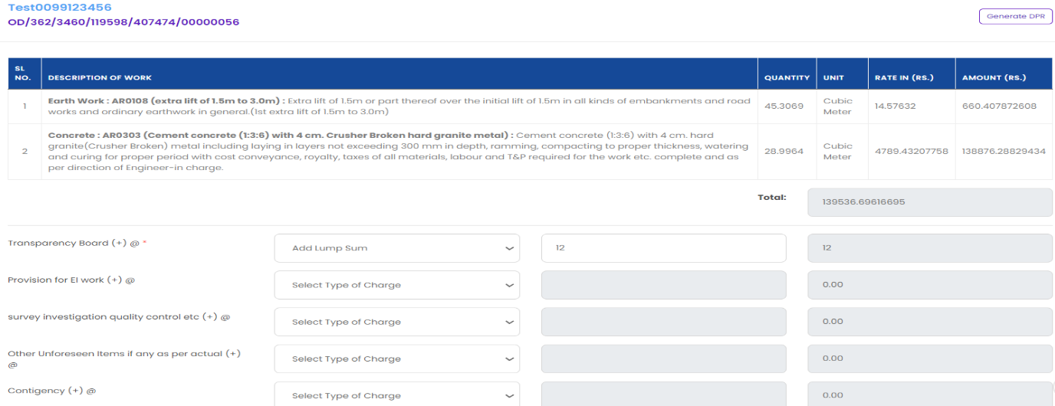
Click here to revert

Here user can view total bill amount

(Fig-26-C)

- Now user need to click on view analysis to view the analysis screen.
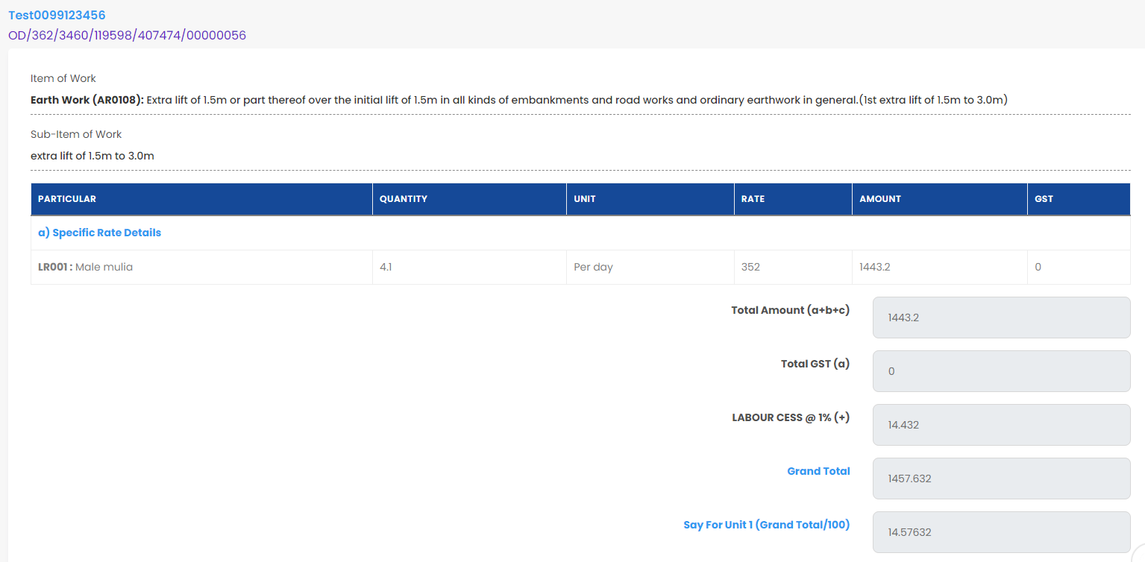

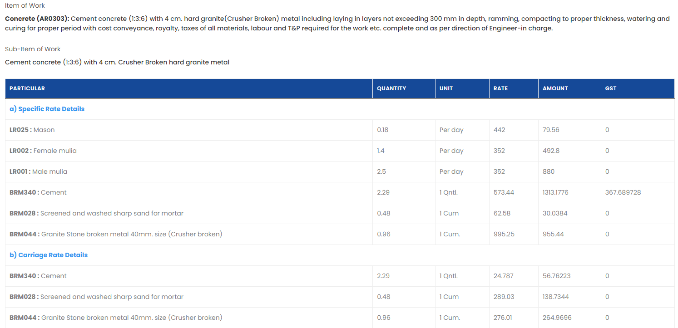

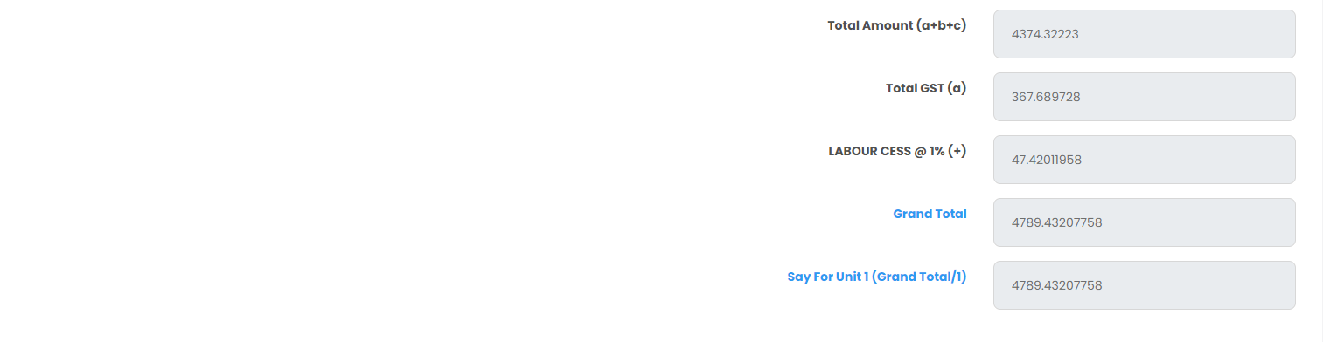
Here user can get total bill amount
(Fig-26-D)
- Now, user will click on Update to Edit Estimate List,
- User need to follow: Estimation>Update.

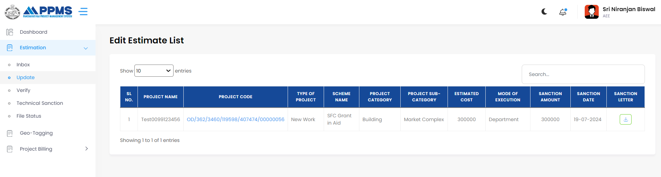
3. Click on Project Code
2.Click on Update
- Click on Estimation
(Fig-27-A)

- Now click on Update to edit the estimate details,

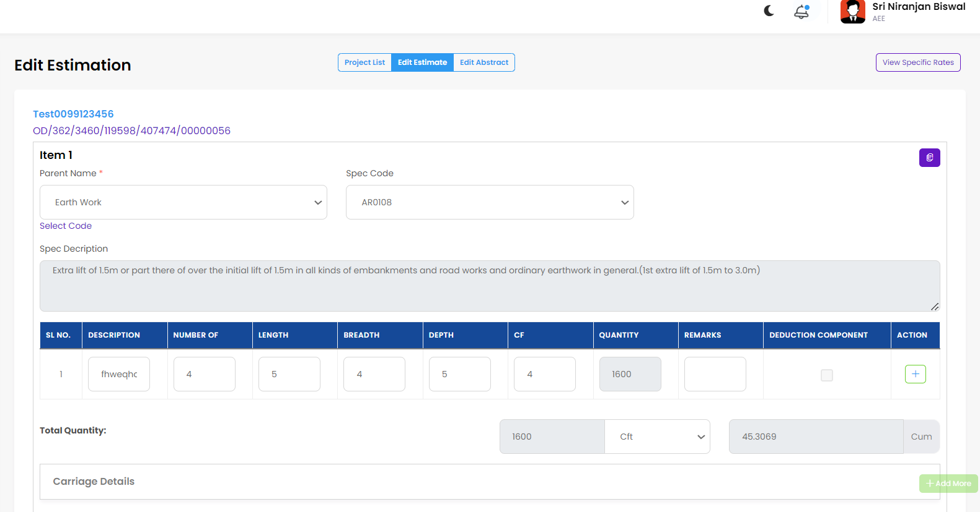
User can edit the estimation here
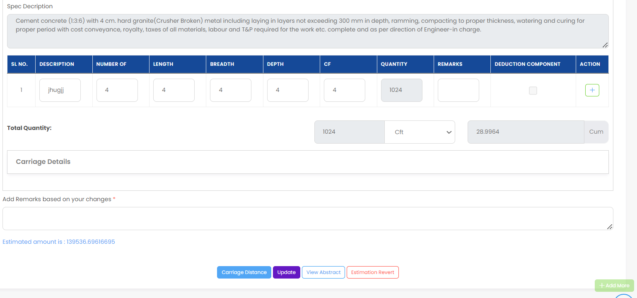
Click here to update the changes
Estimation reverts here
View Abstract
Click on Carriage Distance to edit
Here is the Estimation amount
(Fig-27-B)

- Now click on Edit Abstract to edit the abstract details,

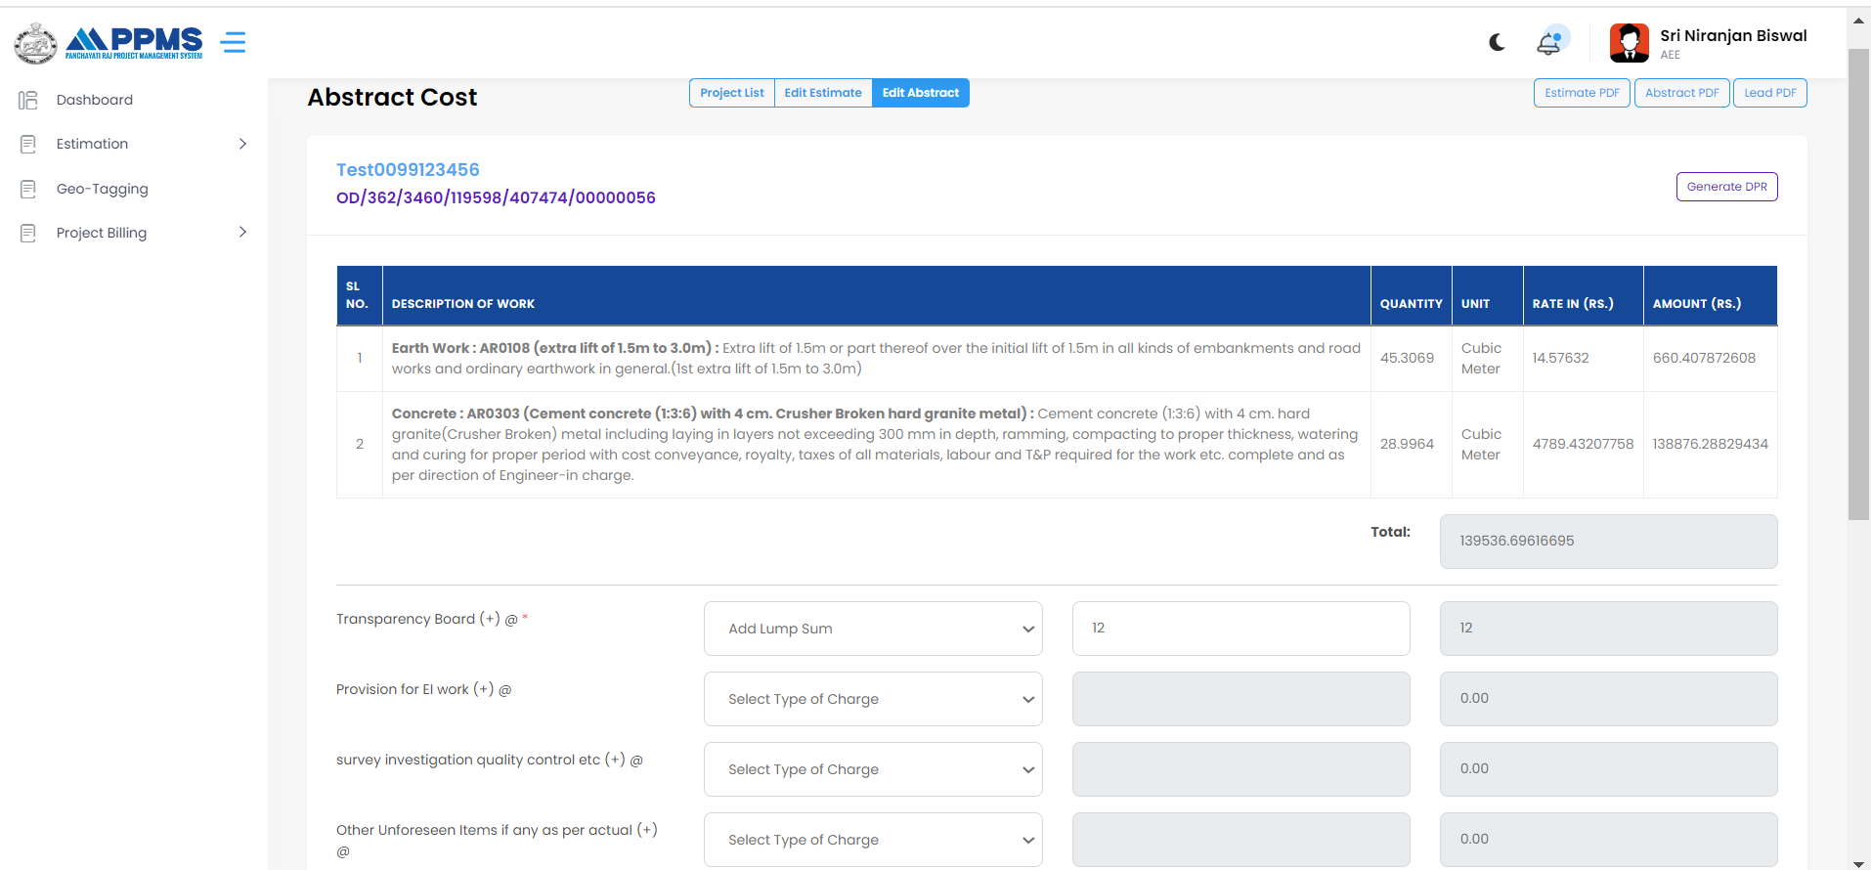
Here user can make the changes in addition (+) and subtraction (-) to make the total billing amount balance
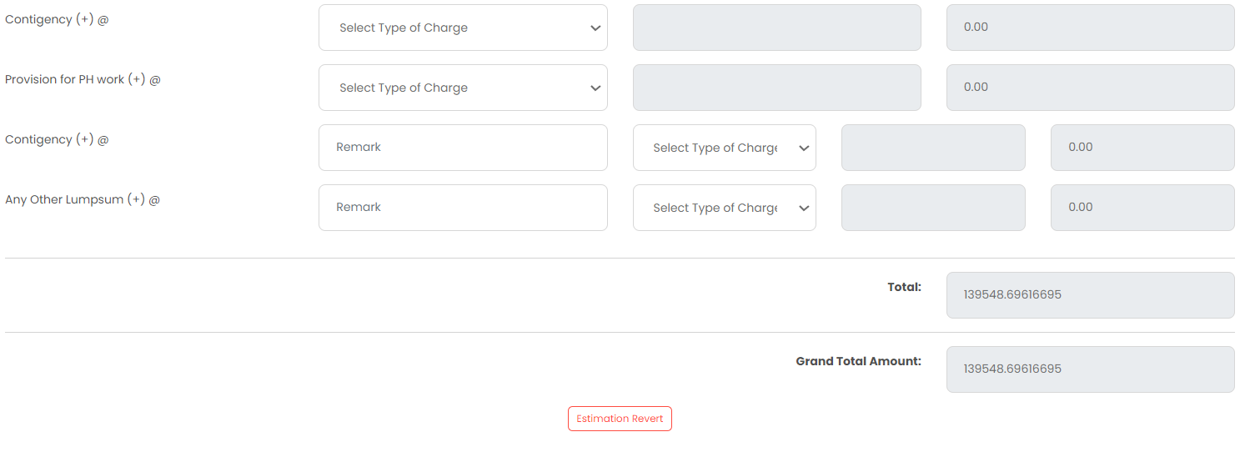
Estimation reverts here
Total billing amount

(Fig-28-A)
- Here user can make the changes in addition (+) and subtraction (-) to make the total billing amount balance.
- User can see Total and Grand Total Amount (Fig-28-A).

- Now time for Technical Sanction,

- AEE user need to click on Estimation below that click on Technical Sanction, now click on view and select the respective Project Code.
Click on the Estimation
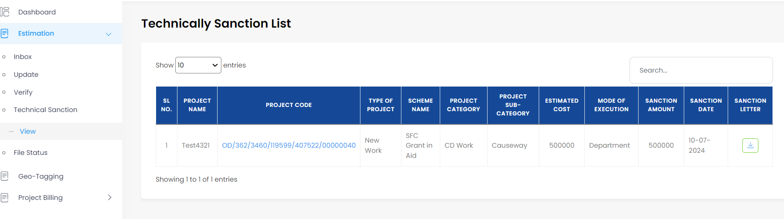
Click on Project Code
Click on View
Now click on Technical Sanction
(Fig-28-B)

- After that enter the Remarks, then click on Sanction Estimation,

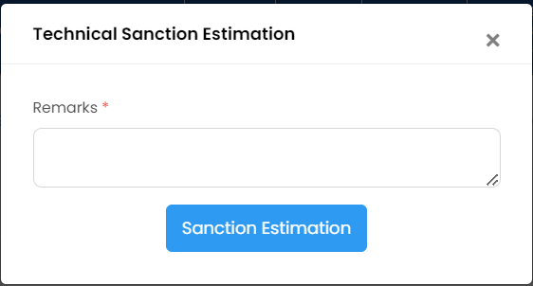
(Fig-28-C)

- After that user will get a Success notification,
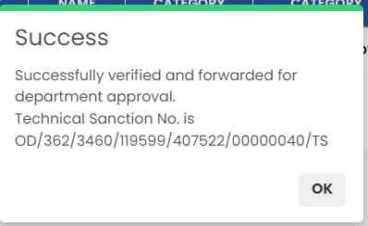
(Fig-28-D)

11. A.E.E User- Verify Estimation

- Now A.E.E User need to verify the estimation by following ways, Estimation>Verify>View.
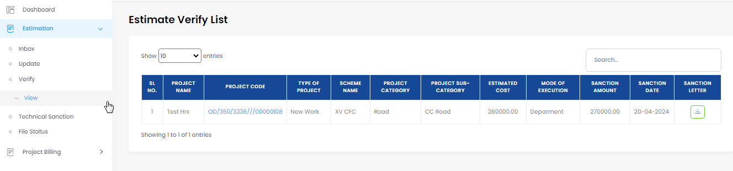
Click on Project Code
(Fig-29-A)
Enter the Remarks

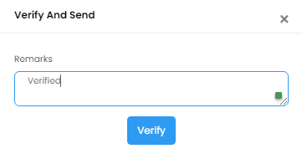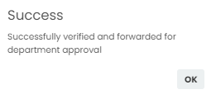
Click here for verify
(Fig-29-B) (Fig-29-C)

- Now after Logged In A.E.E user need to click on Estimation. Under estimation there is a verify option so user need to click on verify and below verify there is an option called view. After clicking on view user now get the screen as Estimate Verify List.
- From the list user need to click on respective Project Code to Verify and Send as shown in the picture No.2
- Now after giving the Remarks, user can click on Verify which leads to Successfully verified and forwarded as shown in the picture No.3.

12. BDO User- Administrative Approval
Criteria: -

- 0-10L-BDO
- 10-20L-Chairperson
- 20-50 AA done by Collector
- 50L more- AA done by Principal Secretary

Here the amount is 5L so AA done by BDO
BDO Login

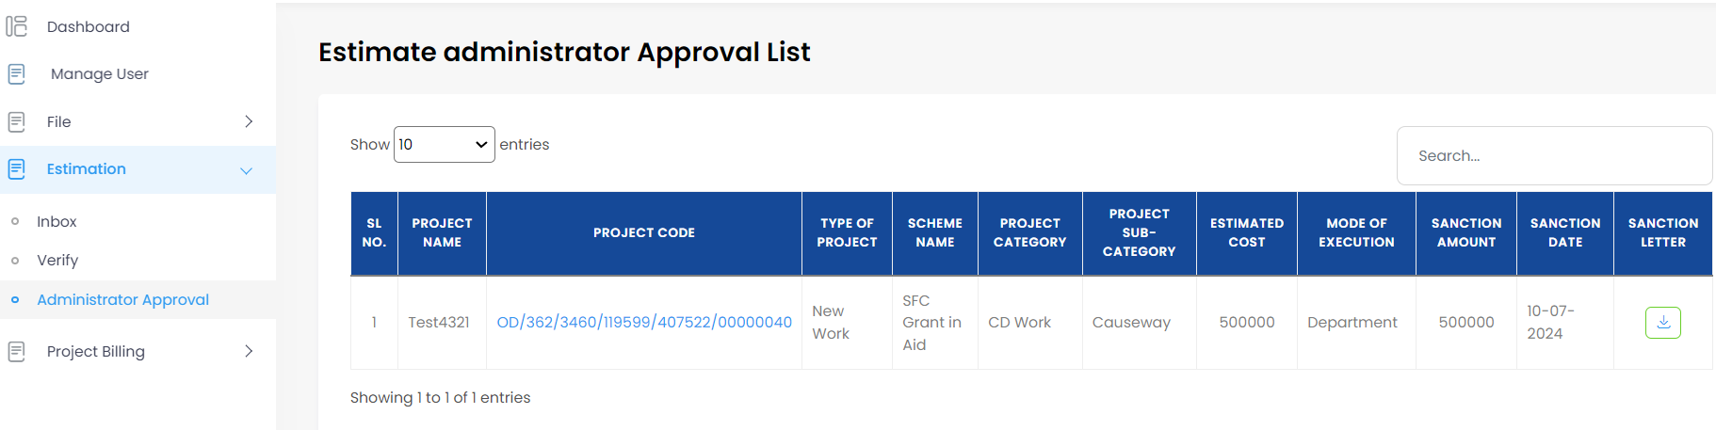
1
2
3
(Fig-30-A)
- User need to click on Estimation below that click on Administrative Approval. Now, user can see Estimate Administrator Approved List. Click on respective Project Code. Follow the sequence 1-3.

Now, user can enter the Remarks,
Now click on Approve
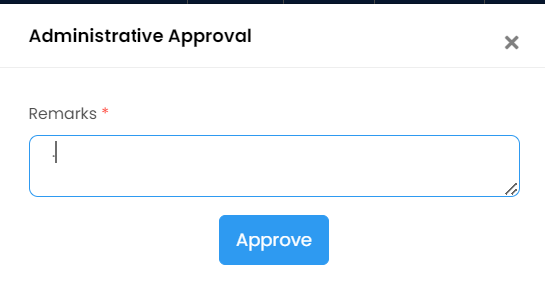
(Fig-30-B)
- Now, user will get a Success Notification,

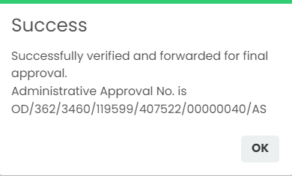
(Fig-30-C)
- If the project is more than 10L then BDO user will Verify it as shown below:
2
1
(Fig-31-A)
- User need to click on Estimation, below that click on Verify if the project is more than 10L.

12.1 BDO User- Assign for Execution

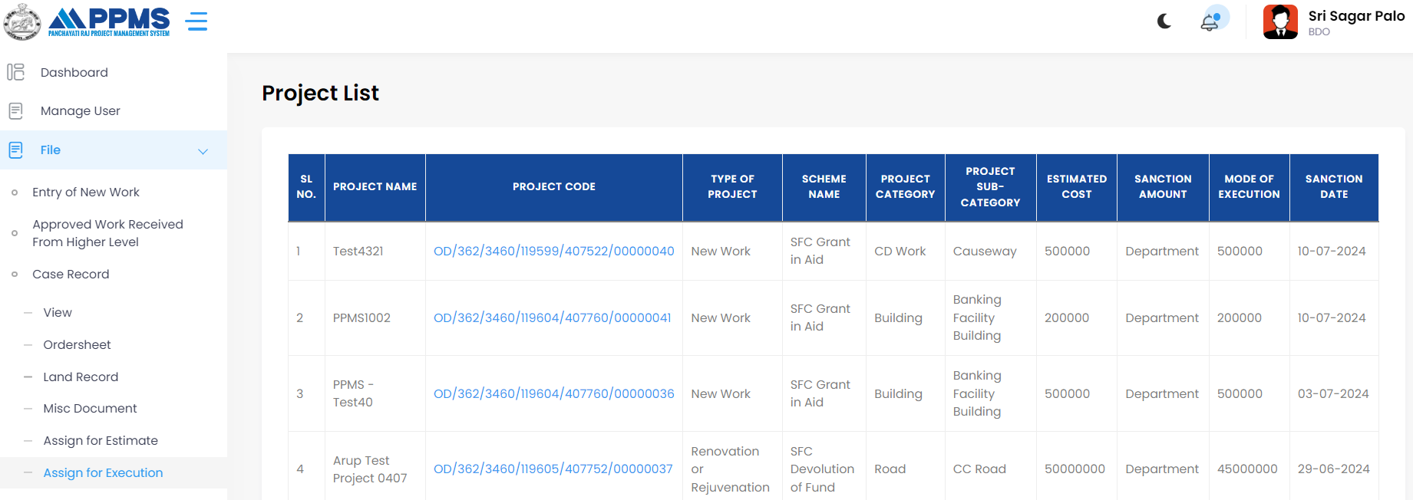
- Before doing the Work Order, user need to do the Execution.

4
1

2

3

(Fig-31-B)

- User need to click on File the click on Case Record below that click on Assign for Execution. Then after display of Project List click on the respective Project Code. Follow the sequence 1-4.

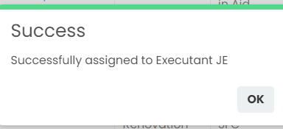
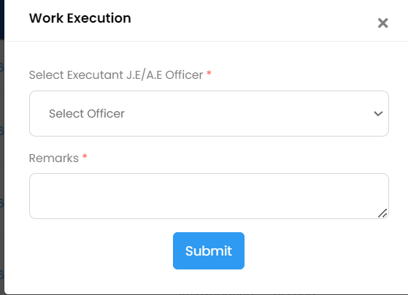 (Fig-31-D)
Click on Submit
Enter Remarks
Select Officer
(Fig-31-C)

- Select Officer and enter the Remarks then click on Submit. After that get a notification as Success.

12.2 BDO User- Generate Work Order

- Follow the below steps to Generate Work Order, follow 1-5
5
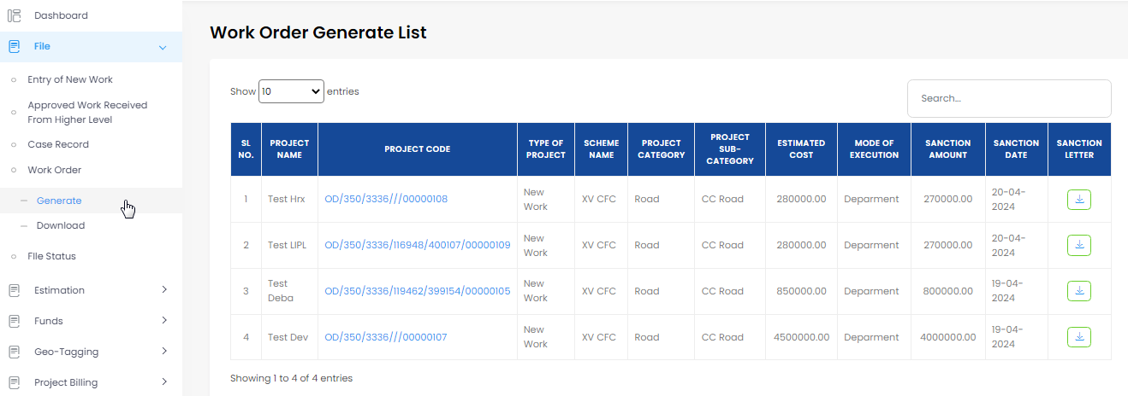
1
3
2
4
(Fig-32-A)

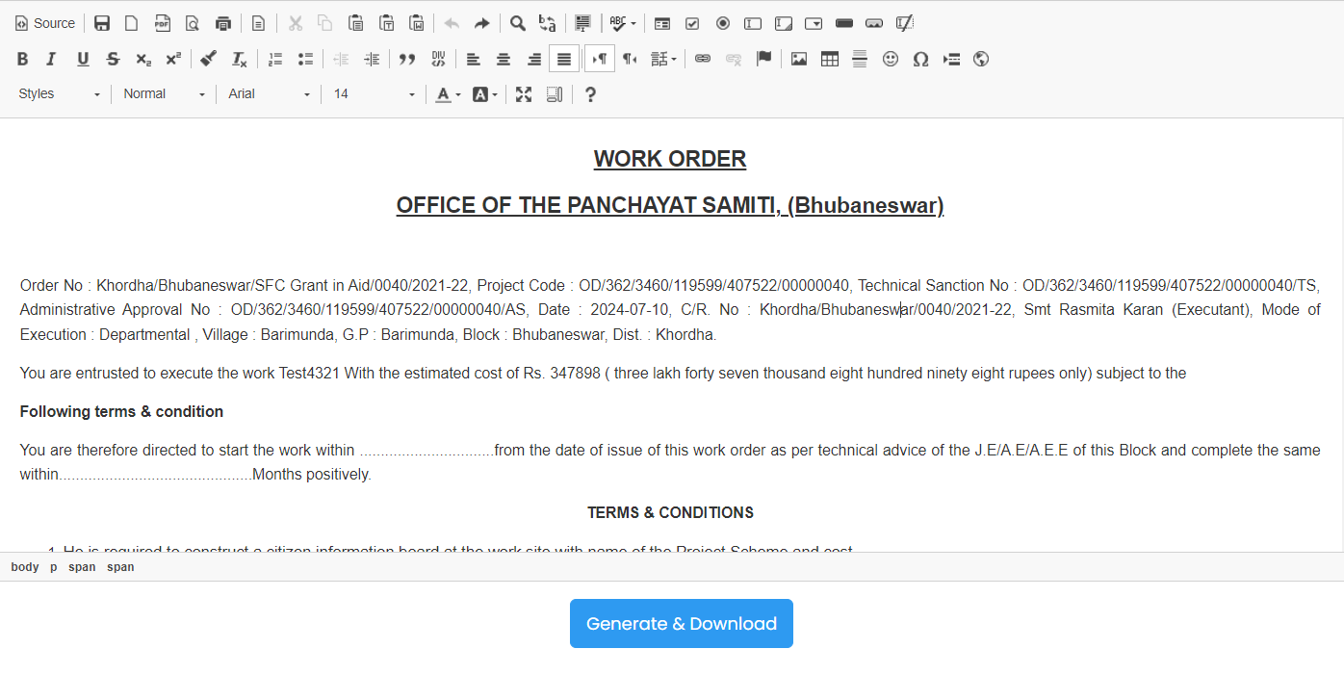

(Fig-32-B)
Editable document

- User need to click on File, then go to Work Order.
- After that user need to click on Generate, as a result user will get a new screen called Work Order Generate List as shown in the picture No. A
- Then user need to click on respective Project Code to view the Work Order. Now user need to click on Generate & Download.
- If the project is above 10L that should be verify by BDO.

13. J.E User- Apply for Billing
- J.E user need to apply for billing. Click on Project Billing>Apply Bill.

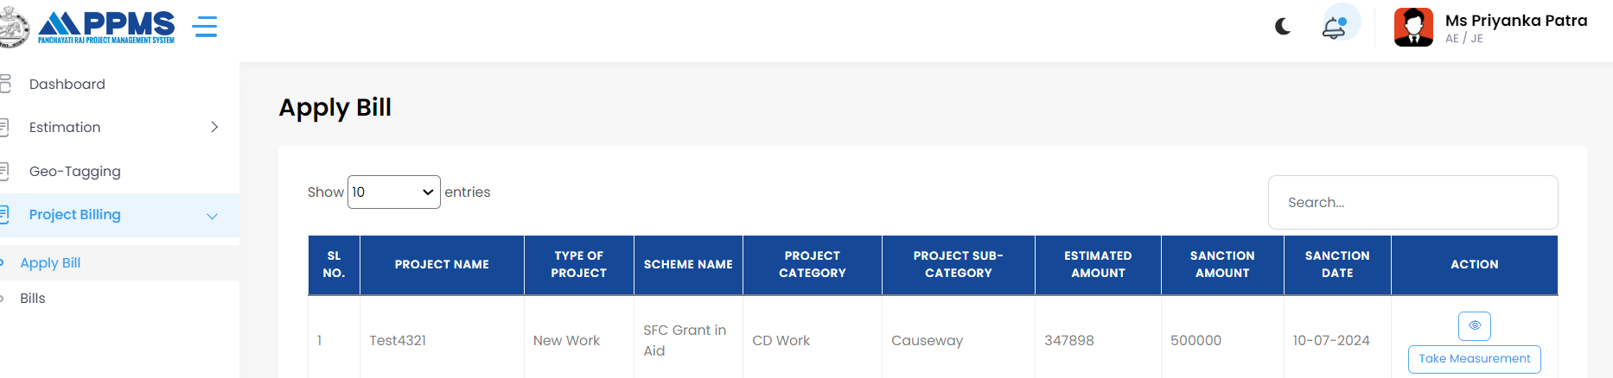
Click here to View Project Info
Click on Take Measurement
(Fig-33-A)
Click here to add measurement
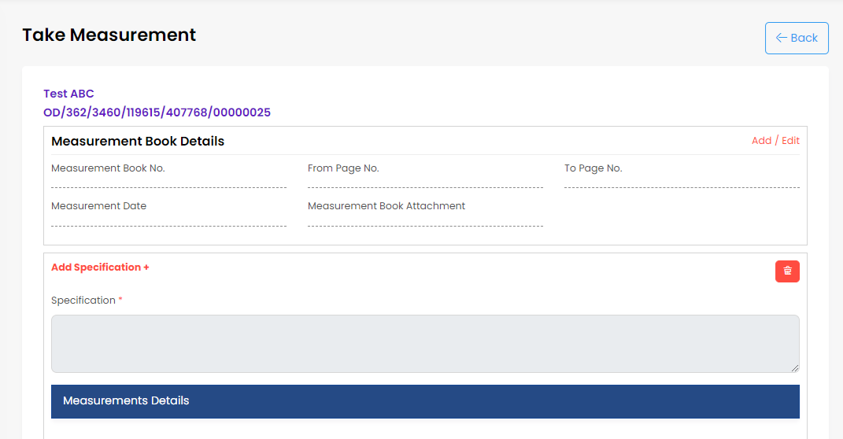
Click here to delete measurement

(Fi g-33-B)
- To display the take measurement (as Fig-33-B) tab, click on take measurement (as Fig-33-A).
- The user fills up all the essential fields after clicking add and save (As Fig-33-C) it.
- And the user has the option to delete.
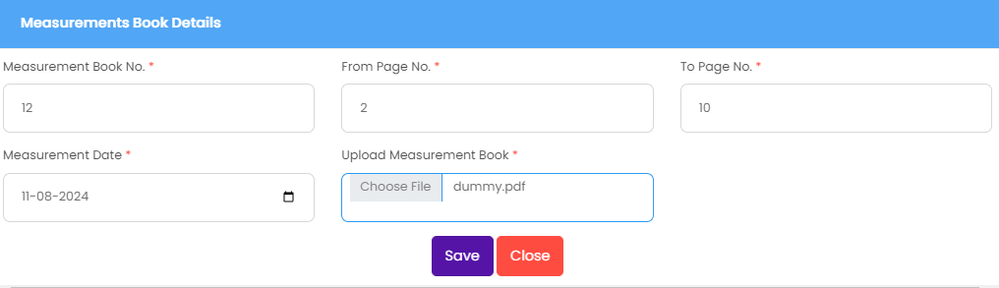

Here we search items
Fill all the required field and save it
(Fig-33-C)
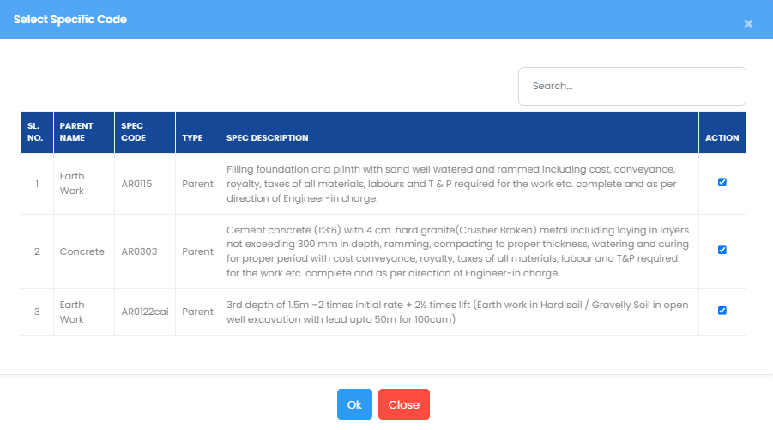
Select all check box
Ok
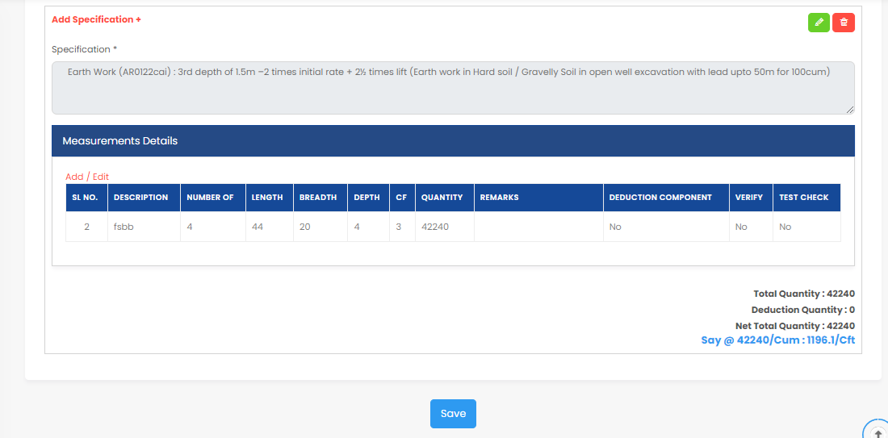
(Fig-33-D)
Save

(Fig-33-E)
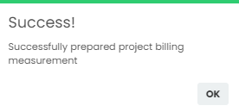
Ok

(Fig-33-F)
- The user clicks the "all" check box, selects ok (As Fig-33-D), and proceeds to search through the objects.
- After save user can edit the Measurement,

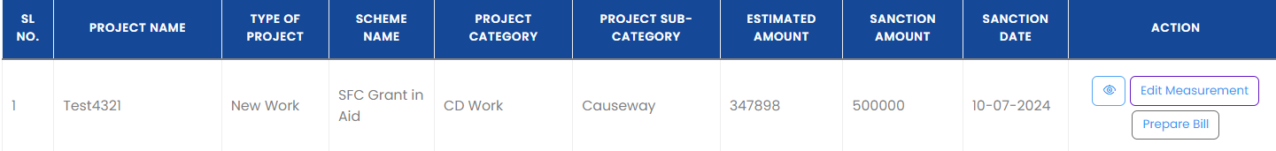
(Fig-34-A)
Click here for Prepare Bill

- Now user need to click on Prepare Bill.
- User can Prepare the and edit the measurement.
User can view the Description of Work, quantity, unit, rate, amount and action

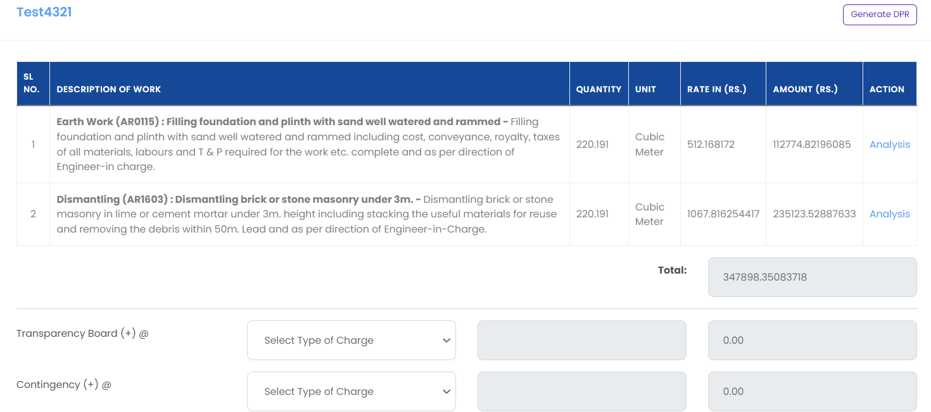
User can do the addition if user wants to add more amount in total bill amount
Select Lump Sum/Percentage
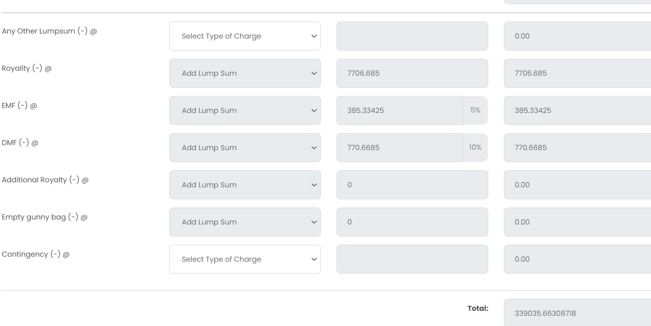
Grand total bill amount
_ indicates deduction if user want deduct the amount from total bill amount
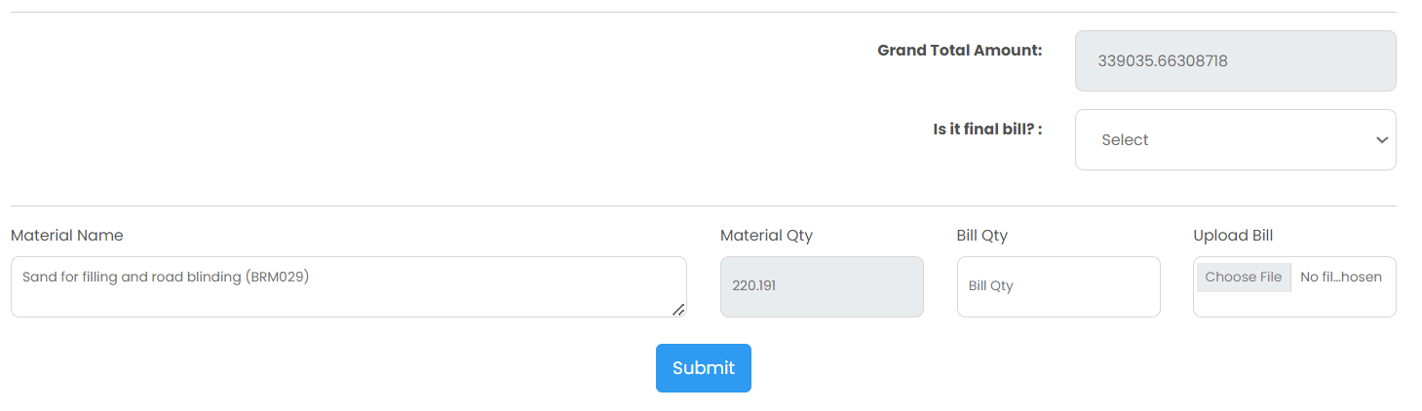
Upload bill
Select Yes/No
(Fig-34-B)
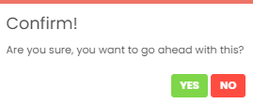

(Fig-34-C)

- The Details Project Report (DPR) is available for download by the user.
- The user completes all required fields and submit button.
- If the user selects "yes" in the confirmation pop-up, it will save.
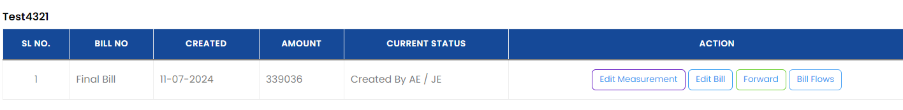 (Fig-34-C)
Forward
- When a user clicks the "forward" button, higher authentication is reached.
- After that Click on Forward,
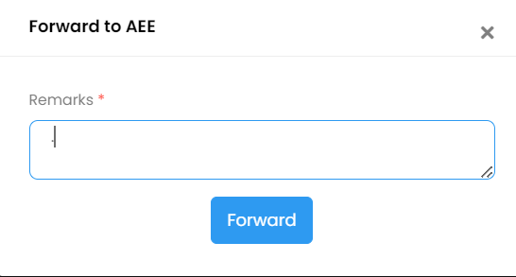

(Fig-34-D)
- Now, enter the Remarks and Forward.

- Get a Notification, forwarded to AEE!
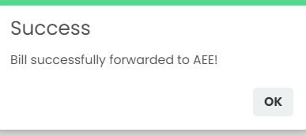

(Fig-34-E)

- The user will successfully forward it if they click "ok."

14. A.E.E User- Verify Billing (Check Measured)

- AEE responsible for verify the pending bill.

- Click on Project Billing>Verify Pending Bill, then select respective project name.

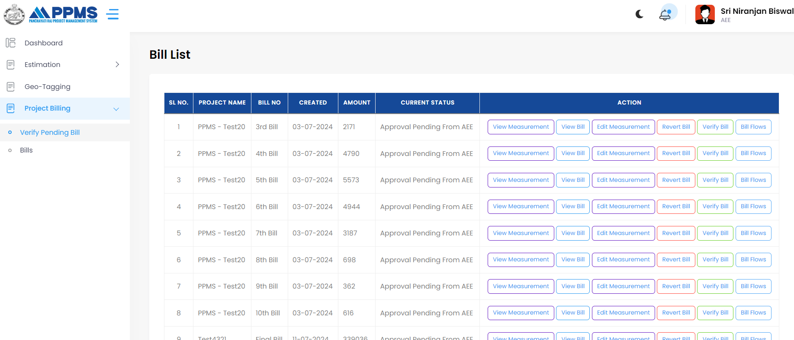
Edit Measurement
View Bill
View Measurement
Select Project Name
Bill Flows
Revert Bill
Verify Bill
(Fig-35-A)
- Here you can get the information such as user View Measurement, view bill, edit measurement, revert bill, verify bill, and bill flows.

- After identifying the project name user need to click on Verify Bill.

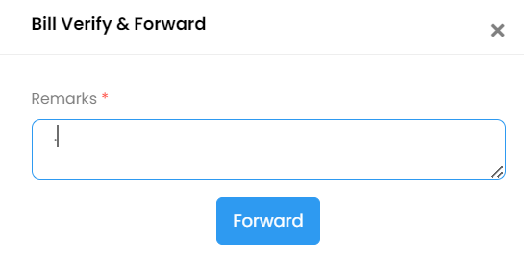
Enter the remarks and click on Forward
(Fig-35-A)
- AEE can do the Check Measure by following ways, click on view measurement,

Click on View Measurement
(Fig-35-B)

- Now AEE can check measure as shown below:
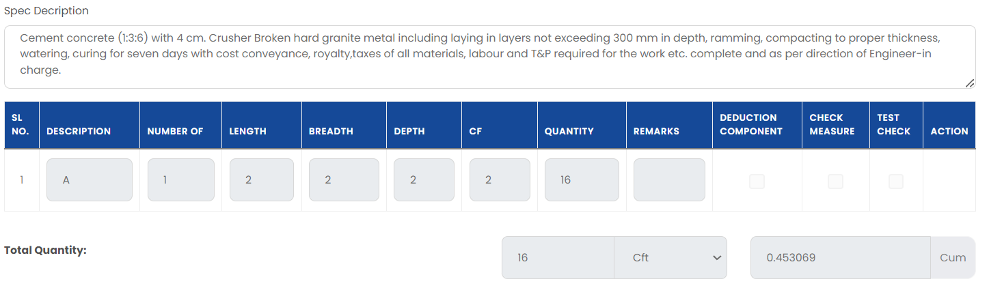
AEO done the TEST CHECK
(Fig-35-C
AEE can CHECK MEASURE here.

15. Section Officer User- Verify Billing

- Section Officer user need to clicks on the “Verify Pending Bill” sub-menu of Project Billing menu for verifying the pending bill.
- Project Billing>Verify Pending Bill>Then select the respective project name.

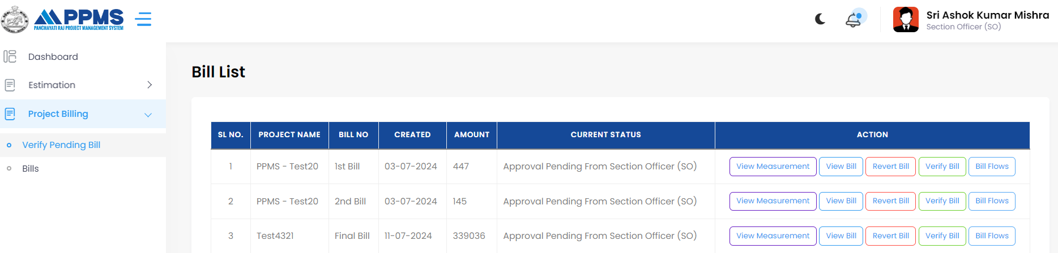
Know the Bill Flows
Verify Bill
Revert Bill
View Bill
View Measurement
(Fig-36-A)

- Here you can get the information such as user View Measurement, view bill, edit measurement, revert bill, verify bill, and bill flows.

- After identifying the project name user need to click on Verify Bill.

- Enter the remarks and click on Forward

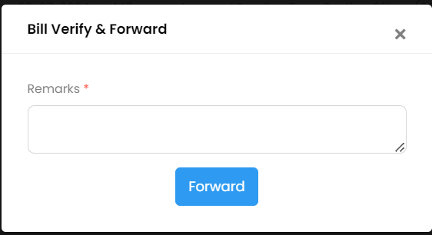

(Fig-36-B)
- Now, bill successfully verified & approved.

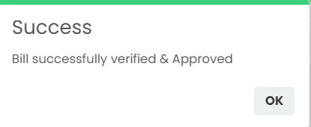

(Fig-36-C)

- When SO click on verify there is a new page appear where SO can add and deduct the component to manage the bill amount.

View Bill
(Fig-37-A)
1

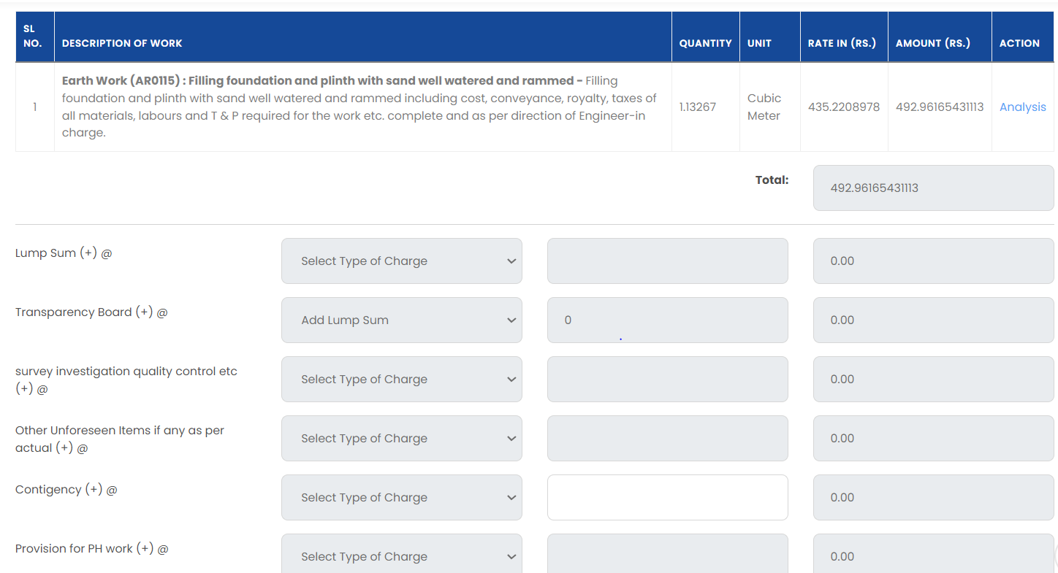
_ indicate the deduction from final bill amount
+ where addition done in the bill amount
2
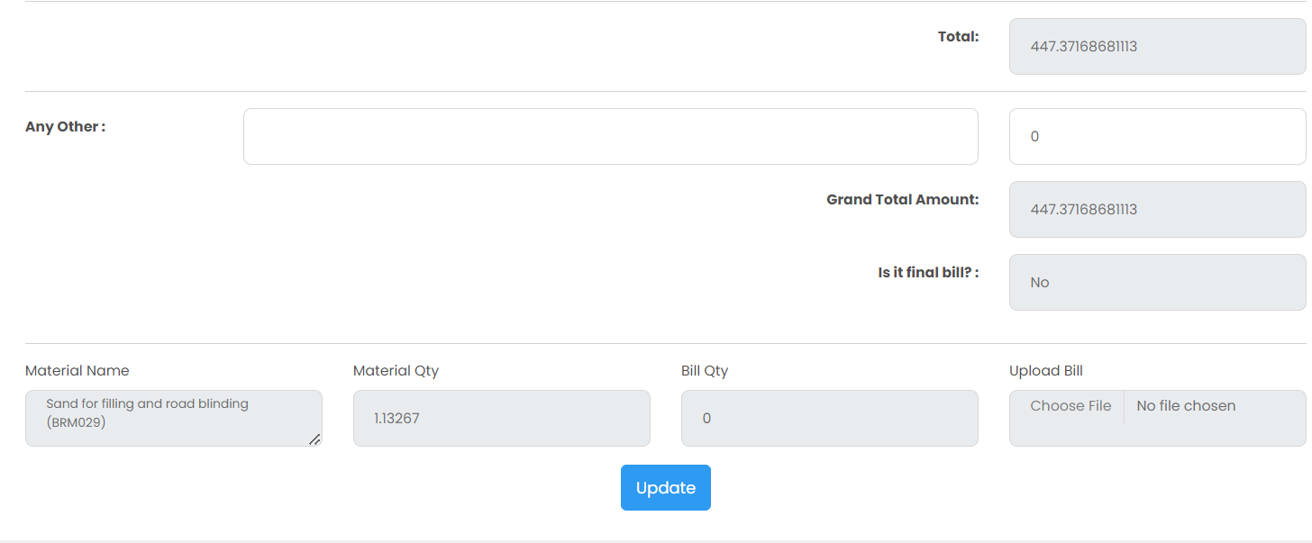
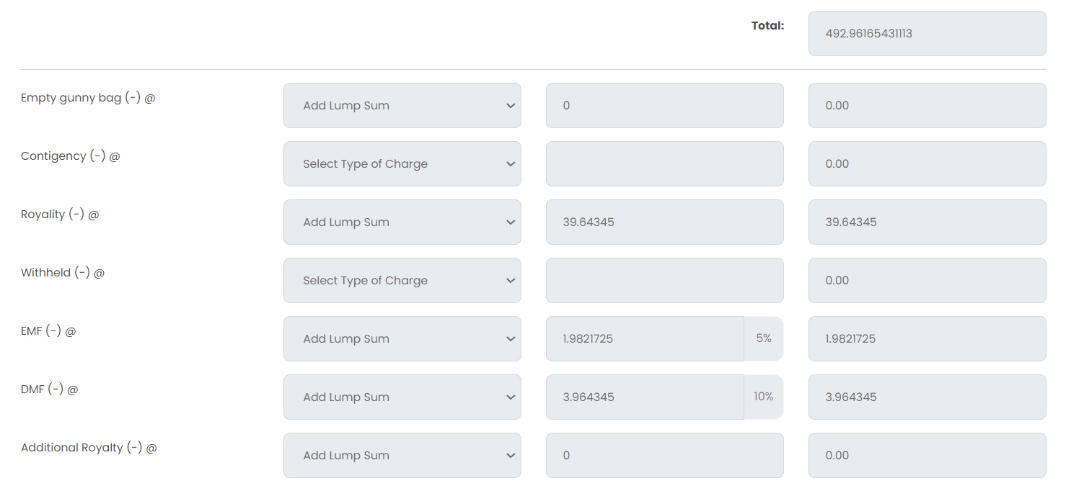
Total Amount
Select Yes/No
Click here to Update

(Fig-37-B)
(Fig-37-B)

16. Accounts Officer User- Verify Billing

- Accounts Officer user need to clicks on the “Verify Pending Bill” sub-menu of Project Billing menu for verifying the pending bill.

- Click on Project Billing Then Verify Pending Bill
1
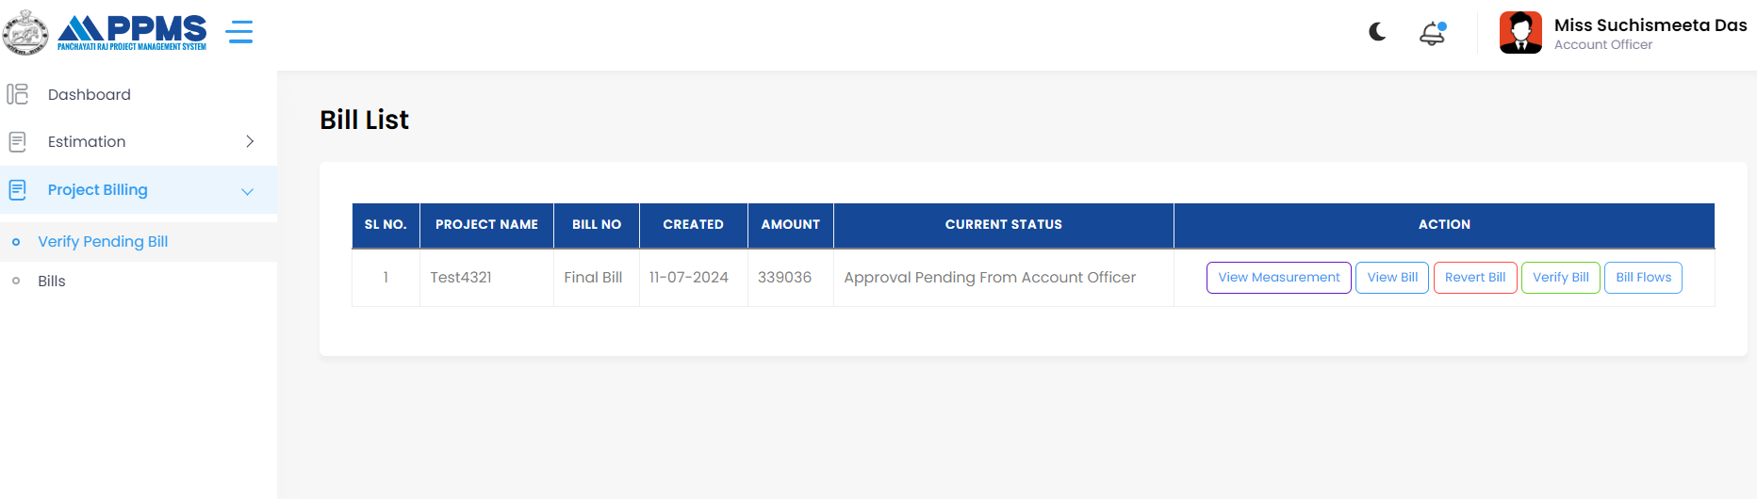
View Measurement
View Bill
Revert
2
Bill Flows
Verify Bill

(Fig-38-A)
- Click on Verify Bill

(Fig-38-B)

- Enter the remarks and forward.

- Now, bill successfully verified & approved.

(Fig-38-B)

- When AO user click on View Bill, there will be a page appear where user can add and subtract component to manage the bill amount.
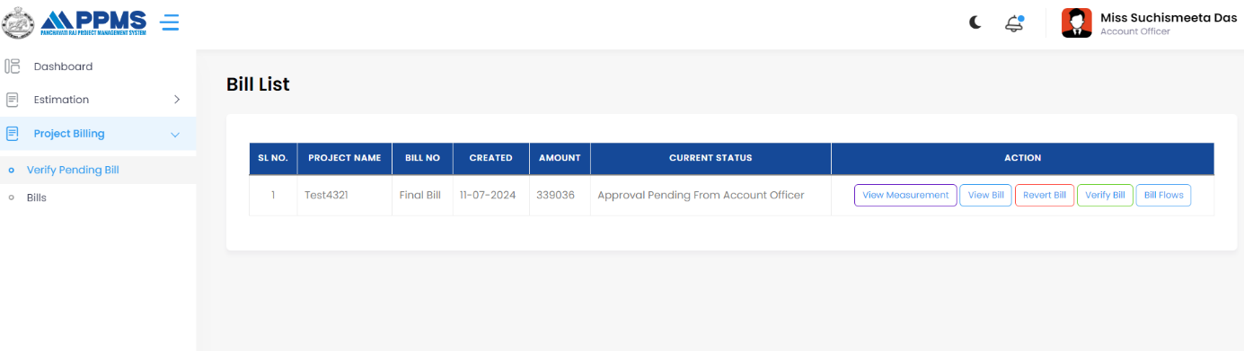

1
View Bill

(Fig-38-B)

+ where addition done in the bill amount

_ indicate the deduction from final bill amount

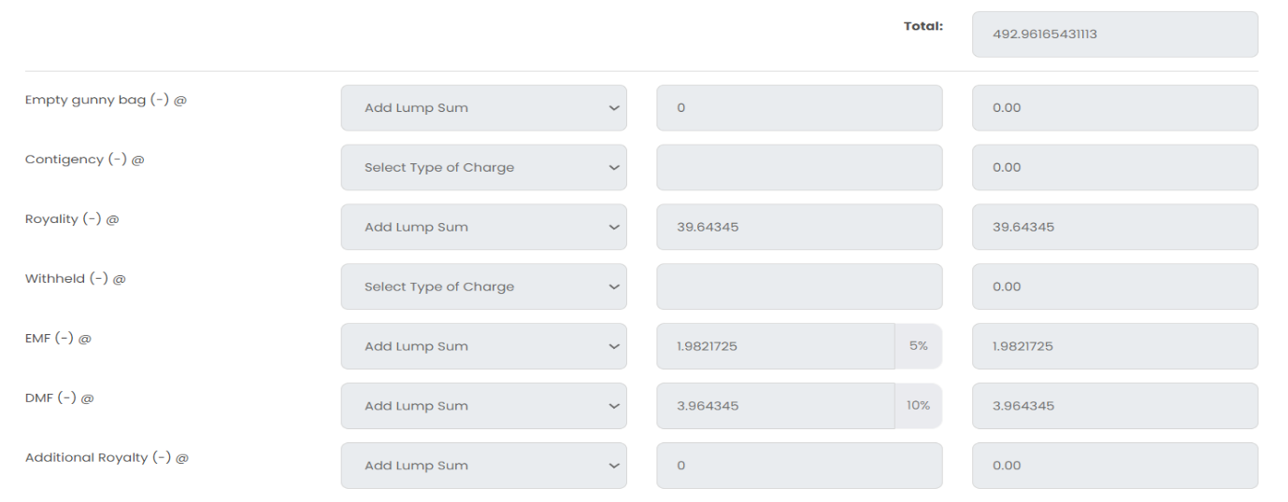
Click here to Update

Select Yes/No
Total Amount

17. BDO User- Verify Billing

- BDO user need to clicks on the “Verify Pending Bill” sub-menu of Project Billing menu for verifying the pending bill.

1

(Fig-38-C)

Revert
Verify Bill
View Bill
View Measurement
Bill Flows
2
(Fig-38-C)
- Click on Verify Bill.

(Fig-38-D)

- Enter the remarks and forward.

- Now, bill successfully verified & approved.

(Fig-38-E)

18. Cashier User- Verify Billing

- BDO user need to clicks on the “Verify Pending Bill” sub-menu of Project Billing menu for verifying the pending bill.

1
Bill Flows
Verify Bill
Revert
View Bill
View Measurement
2
(Fig-39-A)

- Click on Verify Bill.

(Fig-39-B)
- Enter the remarks and forward.

- Now, bill successfully verified & approved.

(Fig-39-C)

19. Cashier User- Generate Bill

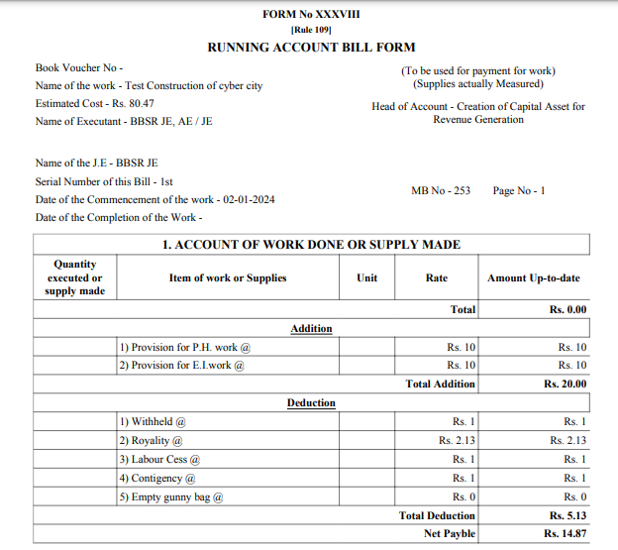

(Fig-40-A)
- User will click on the “Generate Bill” button, which will lead to open Bill page.

20. Reports

- Users can Prepare Handover and Completion Doc by following the below steps.

20.1 Prepare Handover

- Follow the steps 1-3.
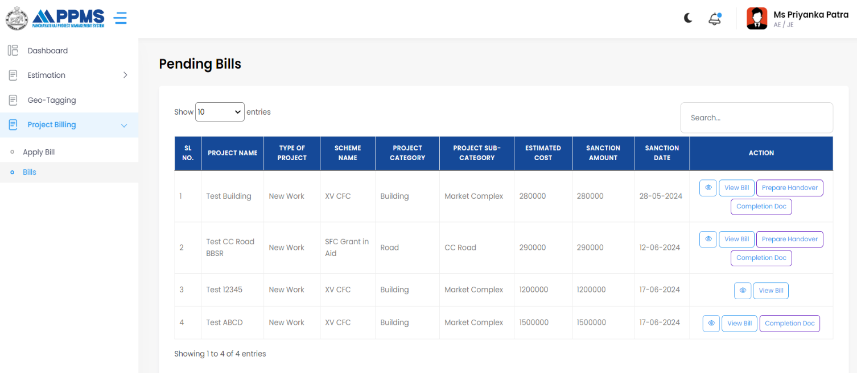
1
Click on Prepare Handover

3
2

(Fig-40-B)

- After clicking on Prepare Handover user will get an editable handover report,
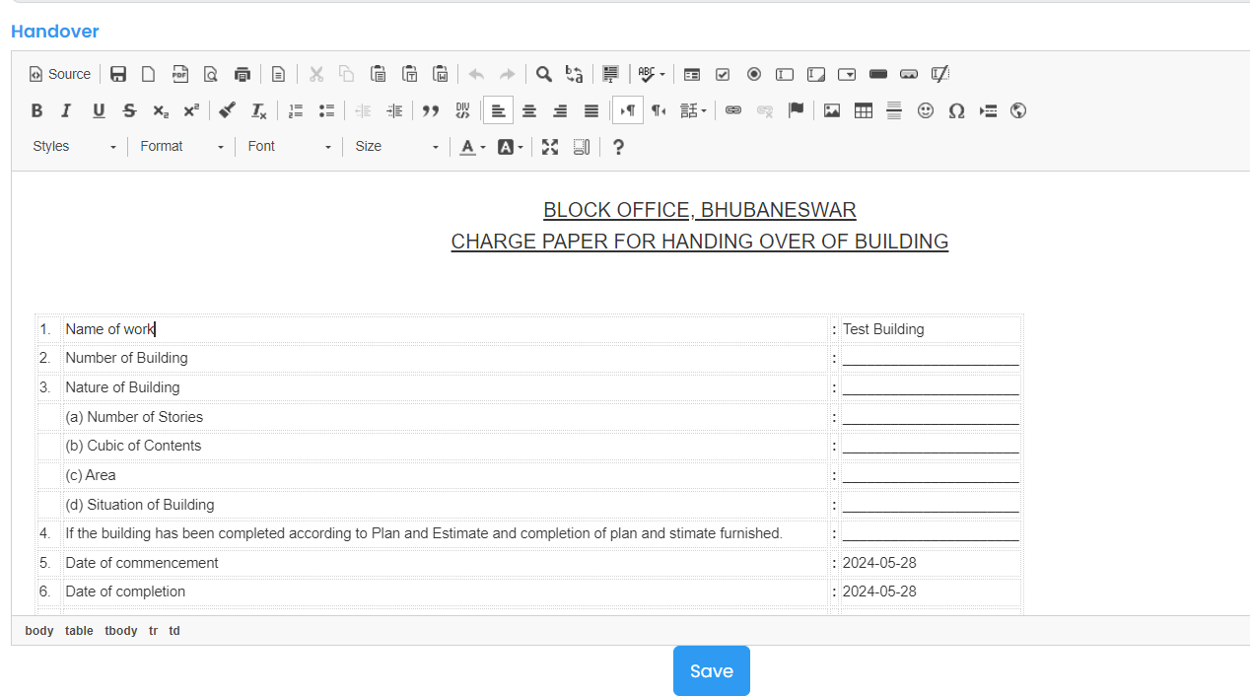
Click here to Save
(Fig-40-C)

20.2 Completion Doc

- Can be done in following ways, follow 1-3.

1
Click on Completion Doc
3
2

(Fig-40-D)

- After clicking on Completion Doc user will get a Completion Certificate,

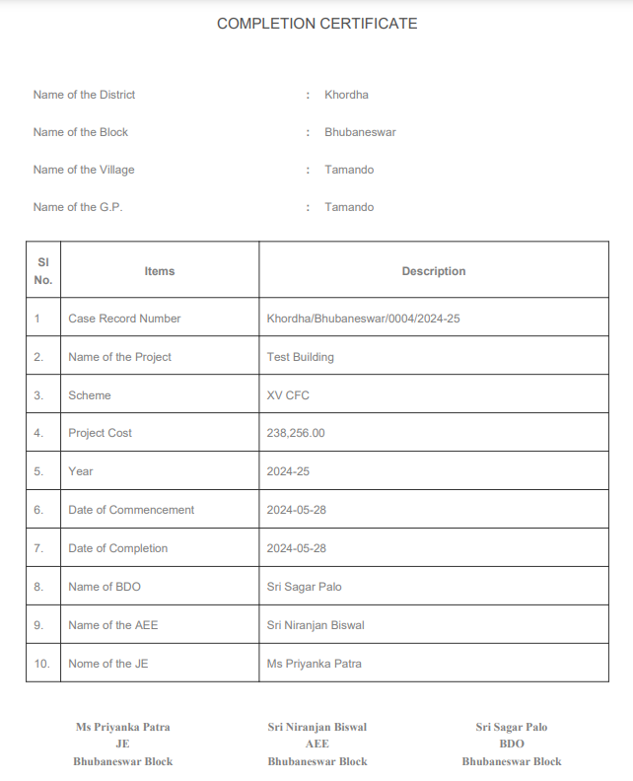
(Fig-40-E)

21. Case Record Report

- User can view the reports and documents related to the project.
- Click on Estimation Then File Status then select on the respective Project Code.

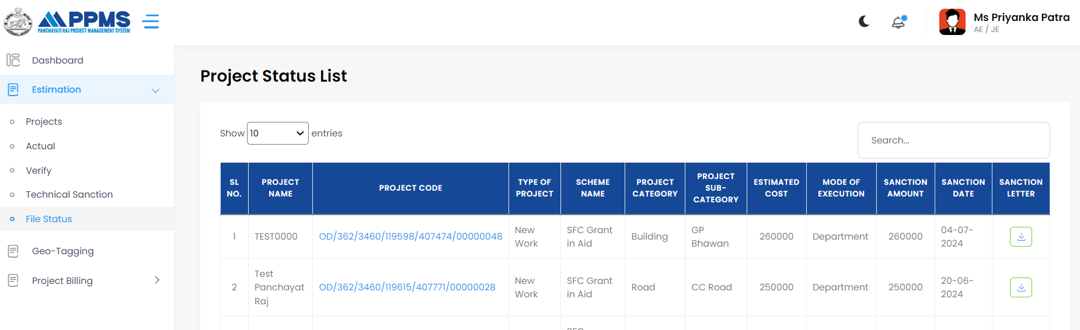
1
3
2

(Fig-40-F)
- Now user can get the Project Info,

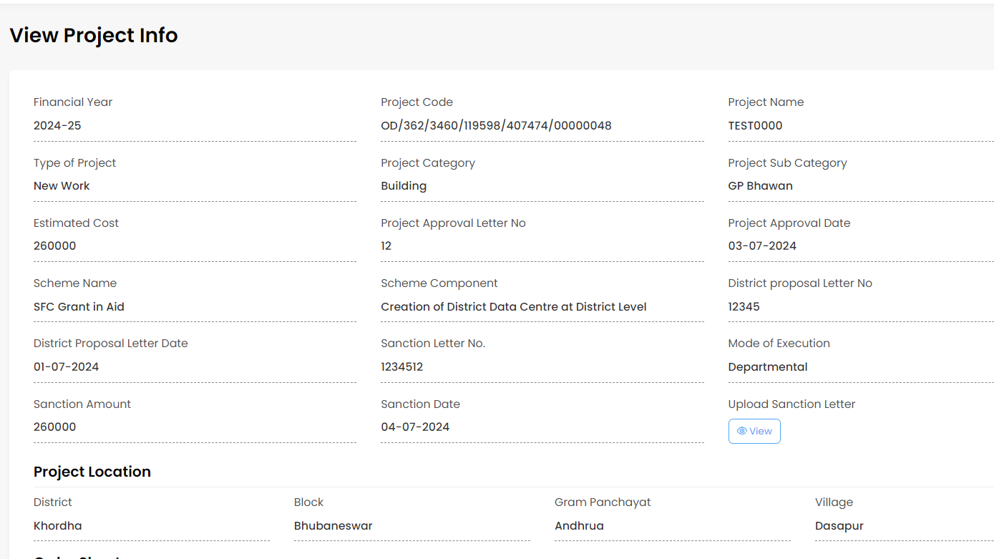

(Fig-40-G)

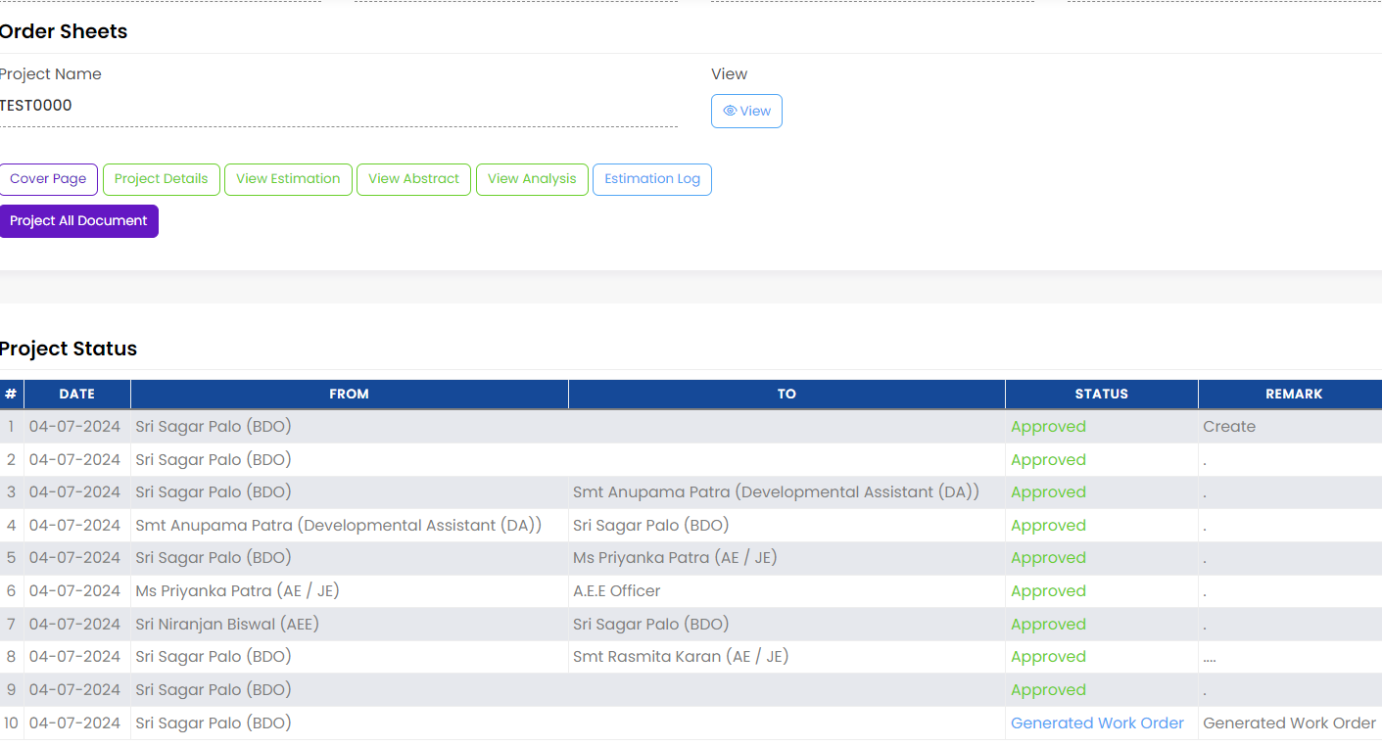
Click on Project All Document
(Fig-40-H)
- Now user can view the document list.
If user select the box here then together all document will select so user able to download all document simultaneously

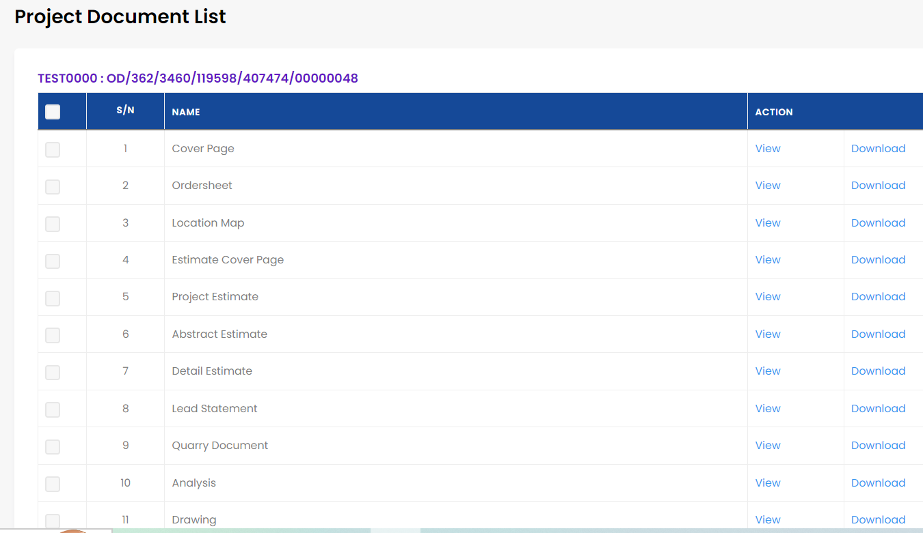
User can download here
View the document here
Individual download can be done by select the box one by one

(Fig-41-A)
- When user click on View, user can view the respective document.

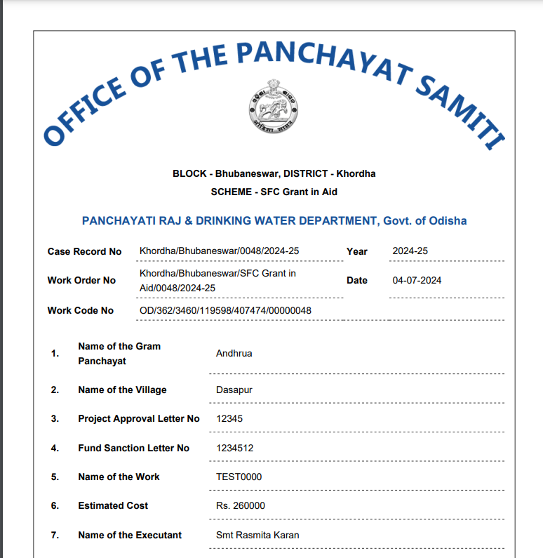
(Fig-41-B)

- When user will click on they can able to download the document.

Thank you

